Introduction to Engineering project

Homeflow navigator



Hatidža Imamović & Farah Mašić

Prof. Tarik Namas

January, 2023

Table of Contents

1. Introduction 2

1.1 A word from the designers 2

1.2 History 2

2. Preparation before the code 3

1. Code breakdown 6

2. Conclusion 6

3. References 6

# **Introduction**

## A word from the designers

Using MATLAB App Designer, we have created a GUI app called HomeFlow Navigator. The applications point of view is trough security cameras placed around the house from which the user can view each room individually, control appliances and get warnings when something is on for prolonged periods of time or when energy consumption is high. Safety is our top priority so you no longer have to worry about leaving your oven on or if intruders will get into your house. With HomeFlow Navigator all of that can be resolved with a click of a button!

## History

The idea of home automated systems was popular in science fiction novels even before the invention of computers. Humans have always known that life on Mars, flying cars and automated homes were a possibility in the far future. With the invention of computers, the idea became more of a possibility even today. We see the first design of a home control system in the 1960s with ECHO or Electronic Computing Home Operator. In the 70s X10 was introduced and later improved. Through X10 users could control lights and other house appliances, but this system was still primitive compared to modern automated systems. With the development of Artificial Intelligence, the internet and application creation, home automated systems have never been more advanced. Everything is moving towards smart control: smart fridges, smart LED lights, smart cameras and so on. Nowadays, many applications exist that serve as remote controls for all of these components and can adapt to any system and any number of devices. These devices can communicate with each other and respond to changing conditions quickly. With more and more improvements to this technology, it is believed that everyone will switch to chips that open houses or even cabinets, fully automated appliances and ways of controlling them in the foreseeable future. Not only is this idea being developed to make our lives easier and more efficient, but also safer. Even those who do not believe in these technological developments are exposed to them through systems like Alexa and Google Home in a way. Clearly, the evolution of home automated systems from concepts in science fiction novels to modern day interconnected devices reflects an ever-evolving need for humans to improve all aspects of our lives.

# **Preparation before the code**

Creating an app is a detailed process, one that cannot start without certain preparations beforehand. Some of these include finding the right background images, finding icon images, picking the sounds you plan on using and more. Many of these are changed in the process and everything is trial and error. Using the Room styler[1] website and other sources[2], our apps initial layout looked more like a collection of pictures.

* 1. Images

Below are all of the images used in the project which were made by us.

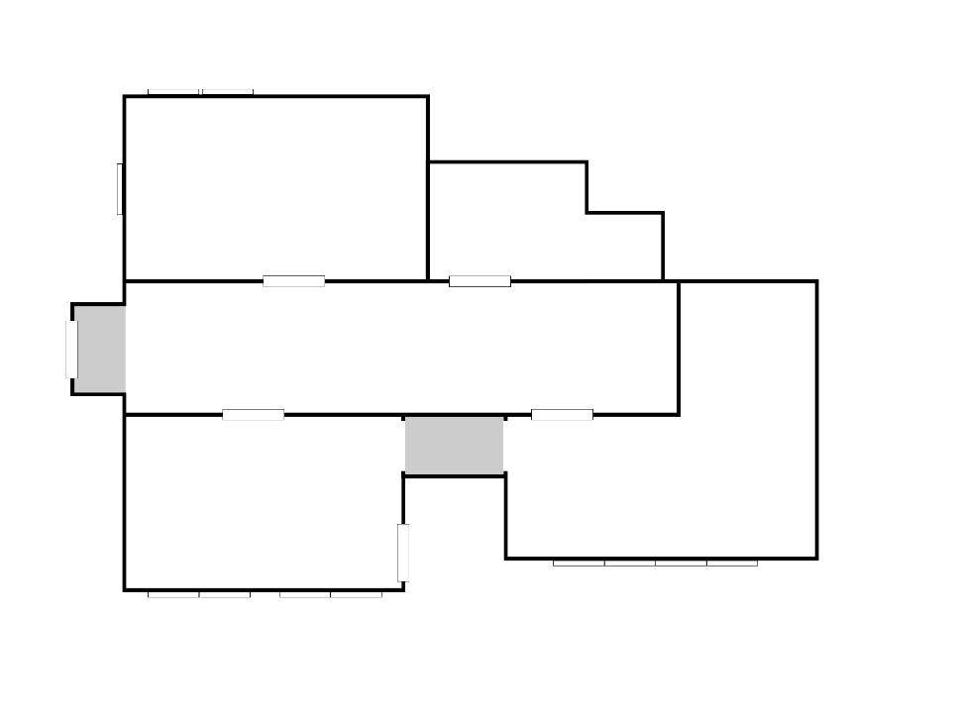

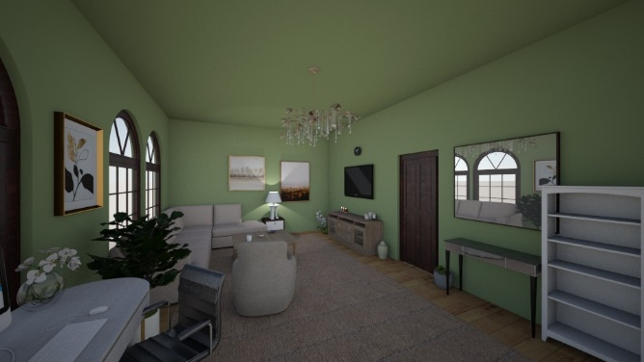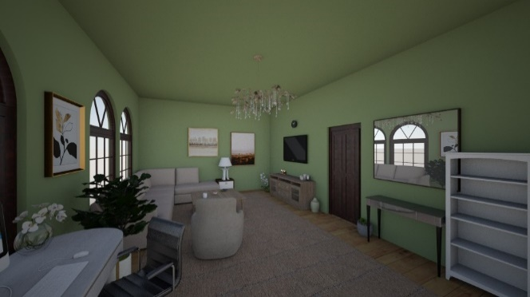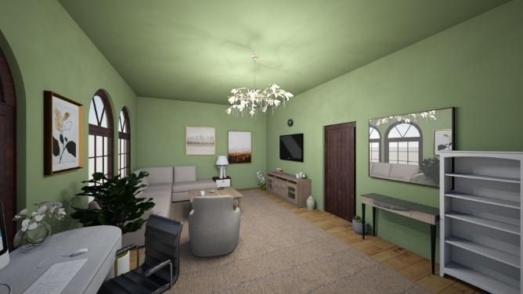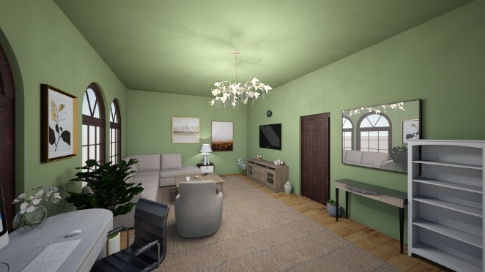Fig 2.1 The image of the house layout which was made by us in Adobe Photoshop (the original file is included in the folder).

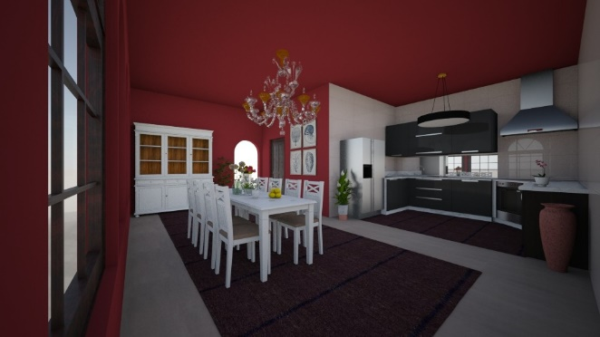Fig 2.2-2.5 The four pictures used for the living room (First picture for case both lights off, second for both lights on, third for only lamp on, and fourth for only main light on). 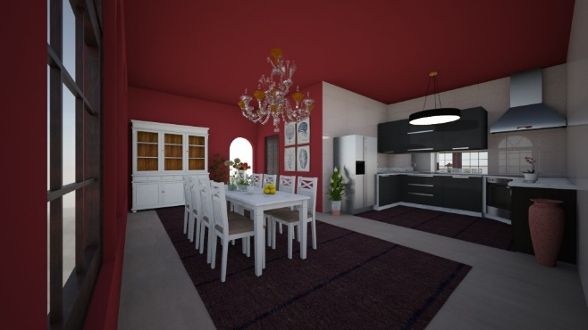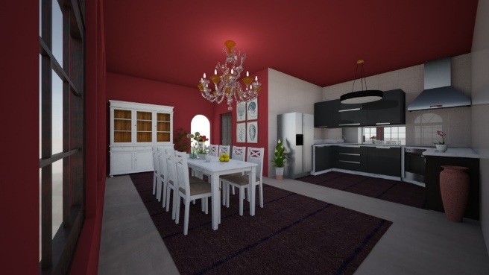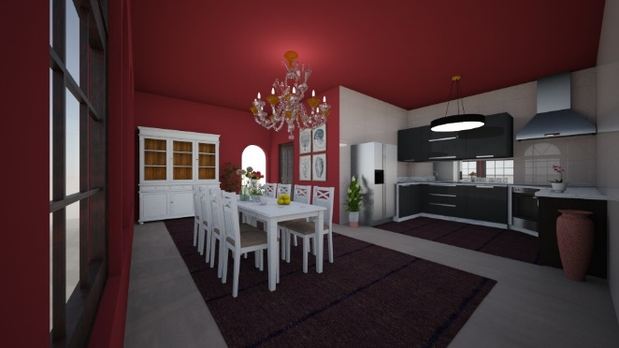

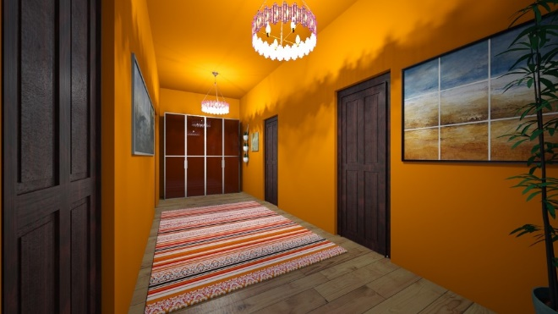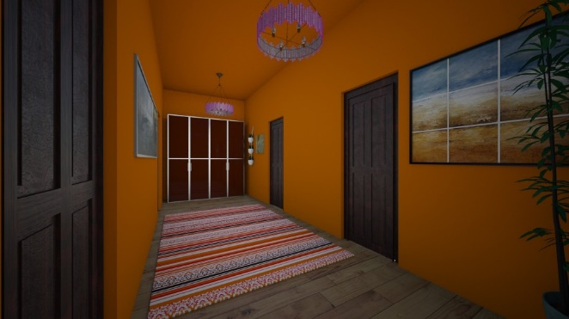Fig 2.6-2.9 Pictures used for the kitchen (First picture in case both lights off, second for both lights on, third for only chandelier on, and fourth for only kitchen light on).

Fig 2.10-2.11 Pictures used for the hallway (First picture in case lights off, second in case lights on).

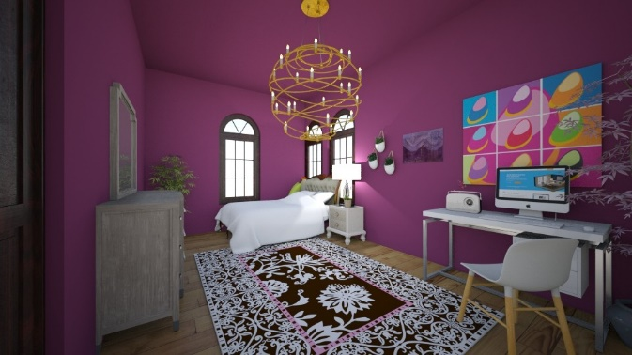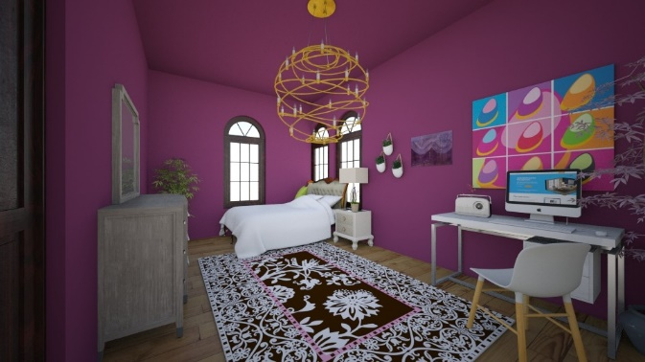

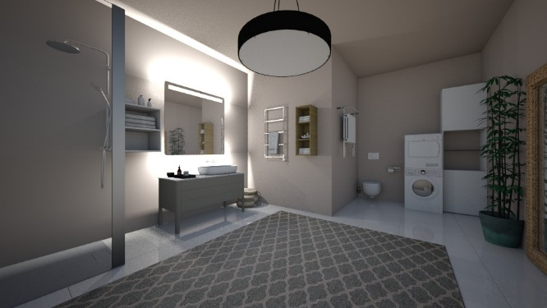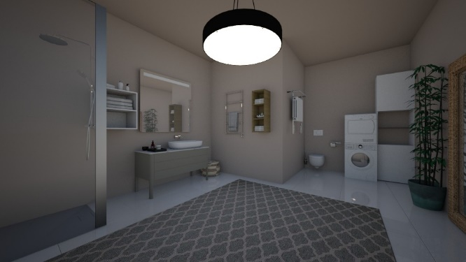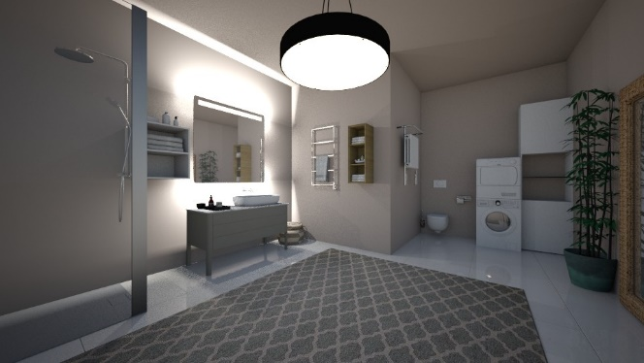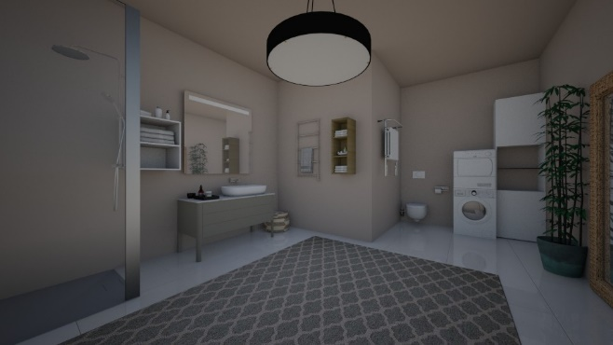Fig 2.12-2.15 Pictures used for the bedroom (First picture in case of both lights off, second for both lights on, third for only the main light on, and fourth for only the lamp on).

Fig 2.16-2.19 Pictures used for the bathroom (First picture in case of both light off, second for both lights on, third for only the light on, and fourth for only the mirror light on).

The rest of the images used were downloaded from the internet. The links for each picture is provided in the references. The images include three background images, 20 icons, a tab image as well as images used for the electrical appliances (such as the oven, washing machine and dryer).

* 1. Audio

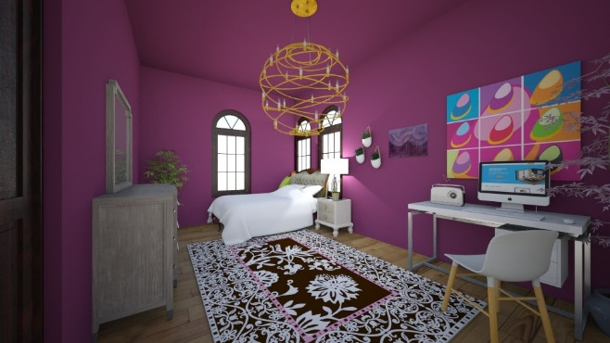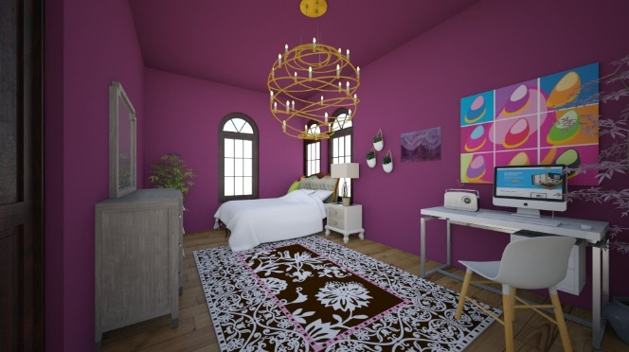In order to enhance the user experience and the overall appearance of the app, various different audio files were included in the making. Below is a list of the audio files used, which were all found and downloaded off the internet. The links for all sounds are available in the references and they are also all provided in the folder with the other files.

The list of the audios used:

* AdDuha.wav
* Avaz.mp3
* Beep sound.wav
* Chipi Chipi Chapa Chapa.mp3
* Click.mp3
* Click.wav
* Dbr.mp3
* Ding.wav
* Door Lock Sound Effect.mp3
* Dryer.wav
* Falestini.wav
* Halal.mp3
* Heater.wav
* LG Washing machine tune.wav
* Light Switch Sound Effect.wav
* MaherZain.wav
* News.mp3
* Oven.wav
* PezaMuslimaneReza.mp3
* Pick.wav
* SwanLake.mp3
* Telenovela.mp3
* Tom Jerry.mp3
* Washing machine.wav
  1. Video

Just like audio, multiple videos were also used to allow the user to shift through channels on the television as one would in real life, and give the effect of an actual television. In addition to those videos, another video was included as the ‘tour of the house’. Below is a list of the videos used in the app, and of course, the references to all the videos are provided at the end of the report, and all of the videos are available in the ‘video’ folder.

The list of the videos used:

* Avaz.mp4
* Chipi Chipi Chapa Chapa.mp4
* Dbr.mov
* Halal.mp4
* News.mp4
* PezaMuslimaneReza.mov
* Telenovela.mp4
* Tour.mov

# **Code breakdown**

* 1. Main page buttons

The main page consists of a combination of different image components as well as two buttons (the START button and the TOUR button).

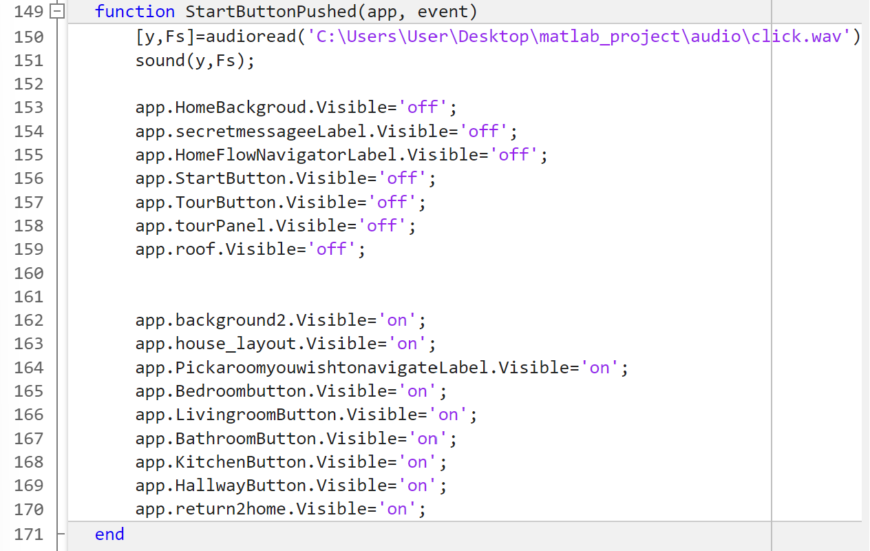

To give the illusion of the user switching different pages in the app, we decided to manipulate the visibility of the app components. Lines 153-159 use the visibility property of the components used for the main page of the app, and by setting the visibility on ‘off’, once the button is pushed, they will become invisible. This makes it look as if the button took the user to a different page, when in reality the button only makes the components disappear and show the other ones which are located beneath.

In an almost identical way, for lines 162-170, we set the components that make up the house layout page to all be visible, in order to make sure that every time the START button is pushed, the house layout page will always be the first part to appear.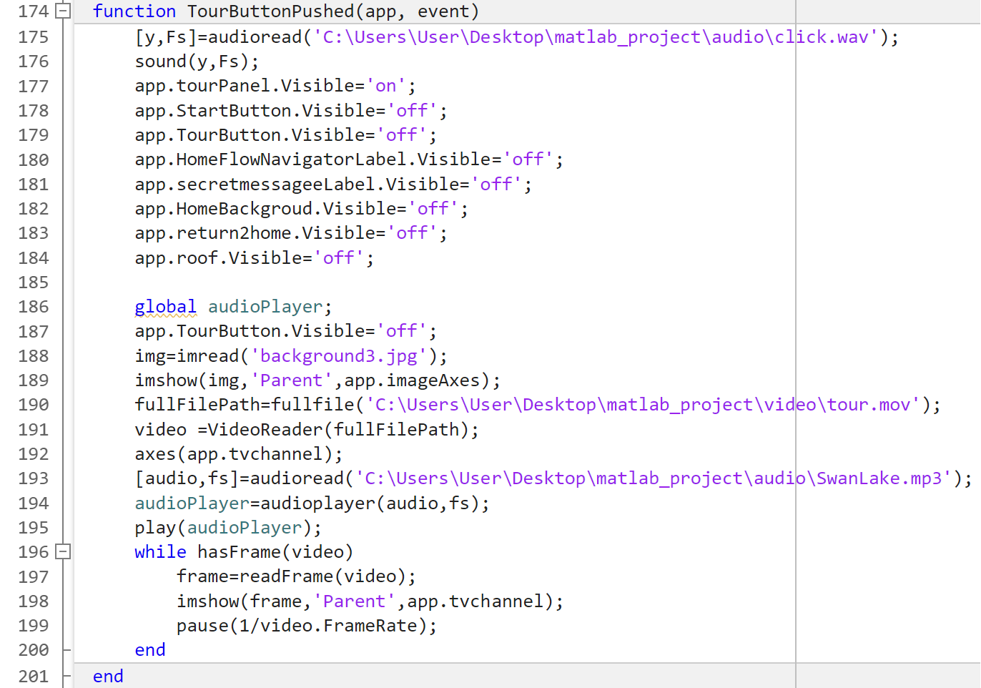

[code explanation]

In the app.tourPanel component, a back button is located that allows the user to exit the tour video at any time. The code for the back button is provided below.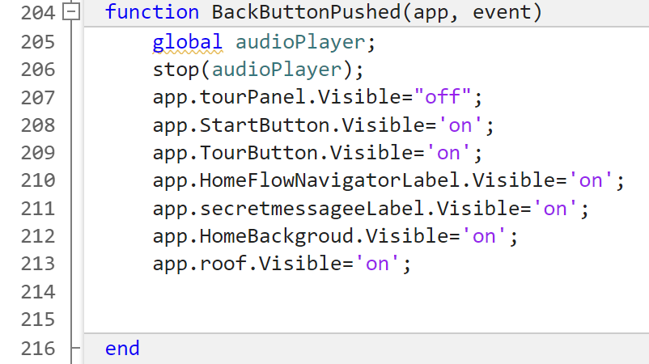Line 207 hides the tourPanel to give the effect of the back button exiting the tour video, while lines 208-213 change the visibility to ‘on’ in order to bring back the home page.

* 1. Return buttons

Multiple return buttons were used in the app, and they all work on the same concept that again manipulates the visibility property of the components shown on screen.

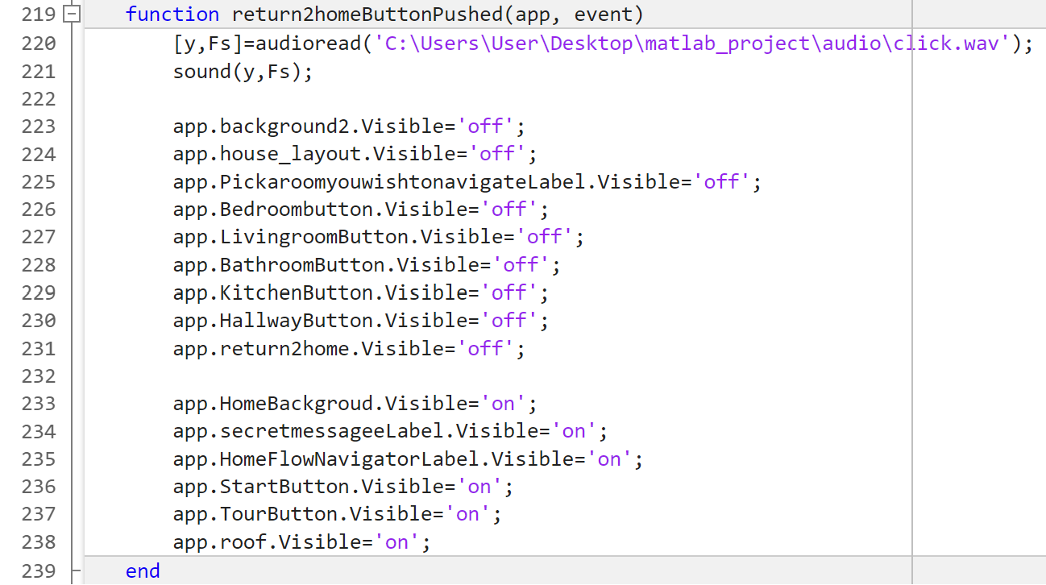

Lines 223-231 set the current house layout page to become invisible once the button is pushed, and in return (lines 233-238) set the first app components that make up the main page visible once more. This gives off the effect of a return button, allowing the user to navigate from the main page and the layout page.

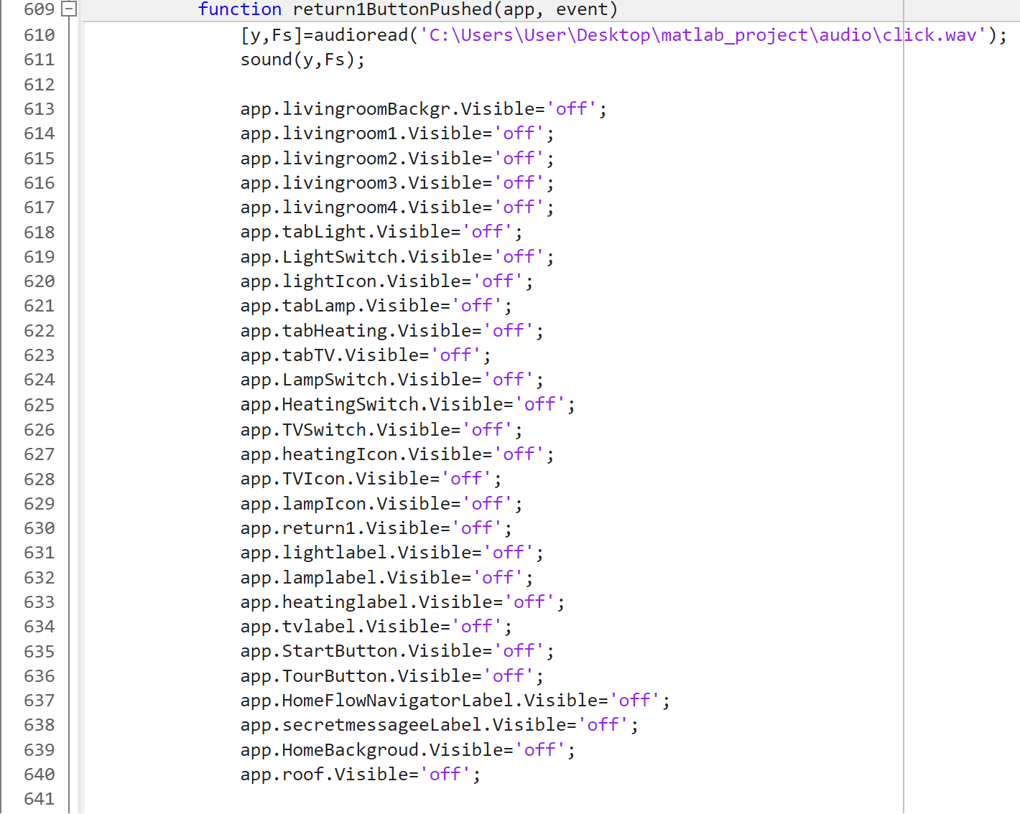

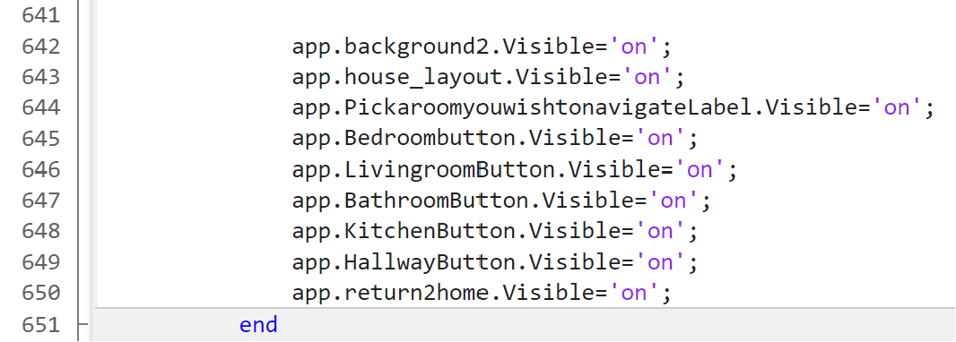

Above is the code for the return button in the living room page.

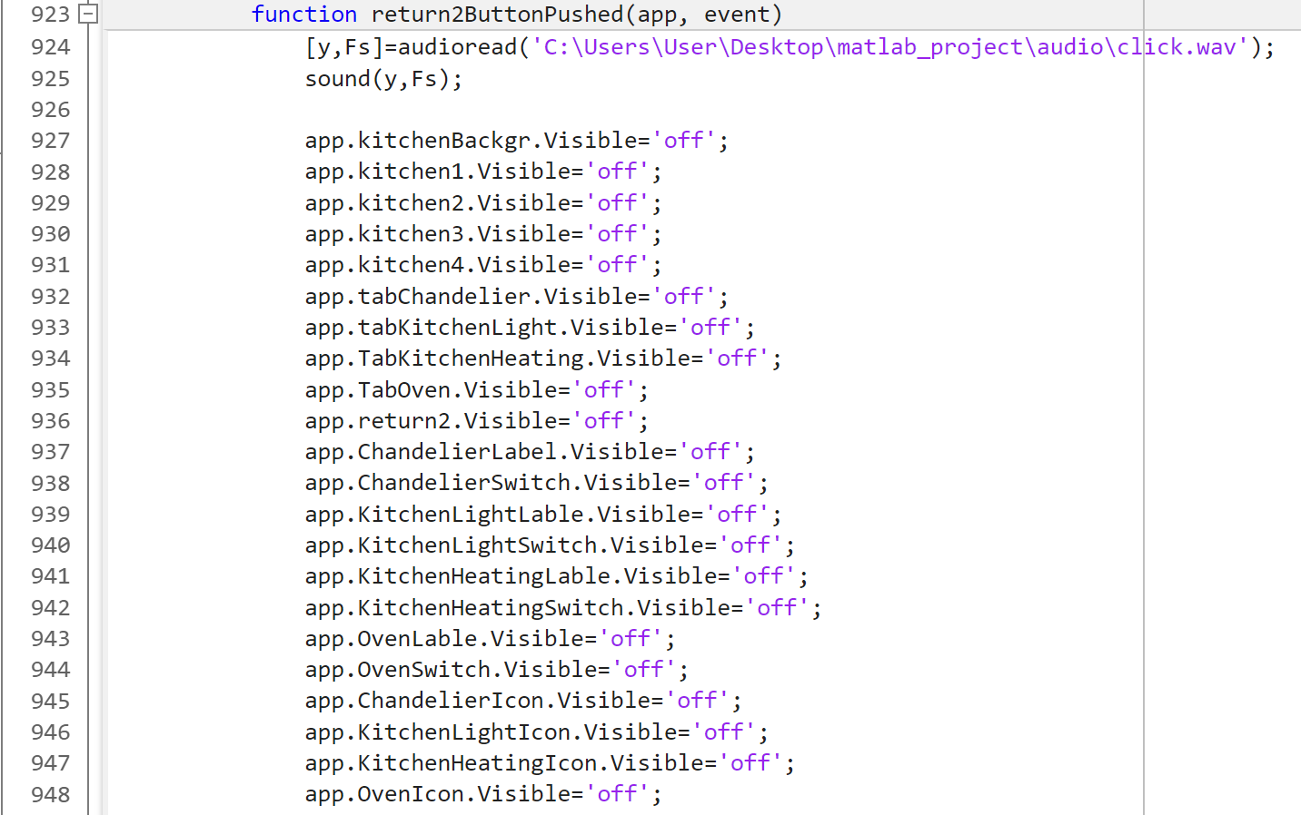

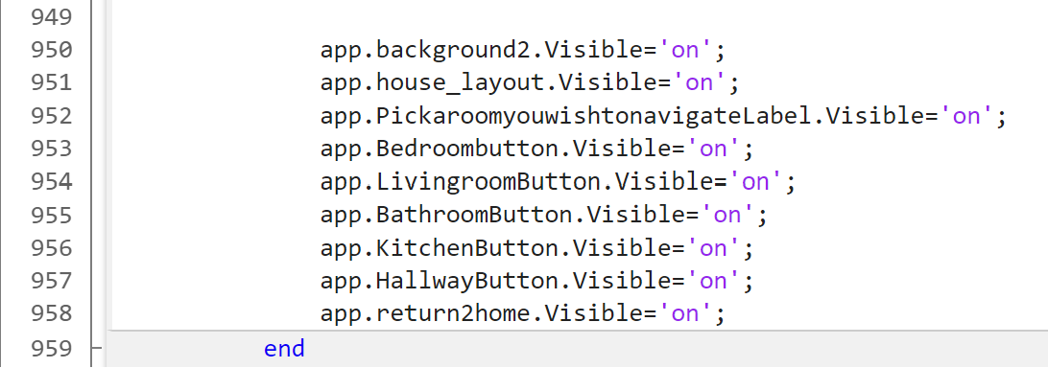

Above is the code for the return button in the kitchen page.

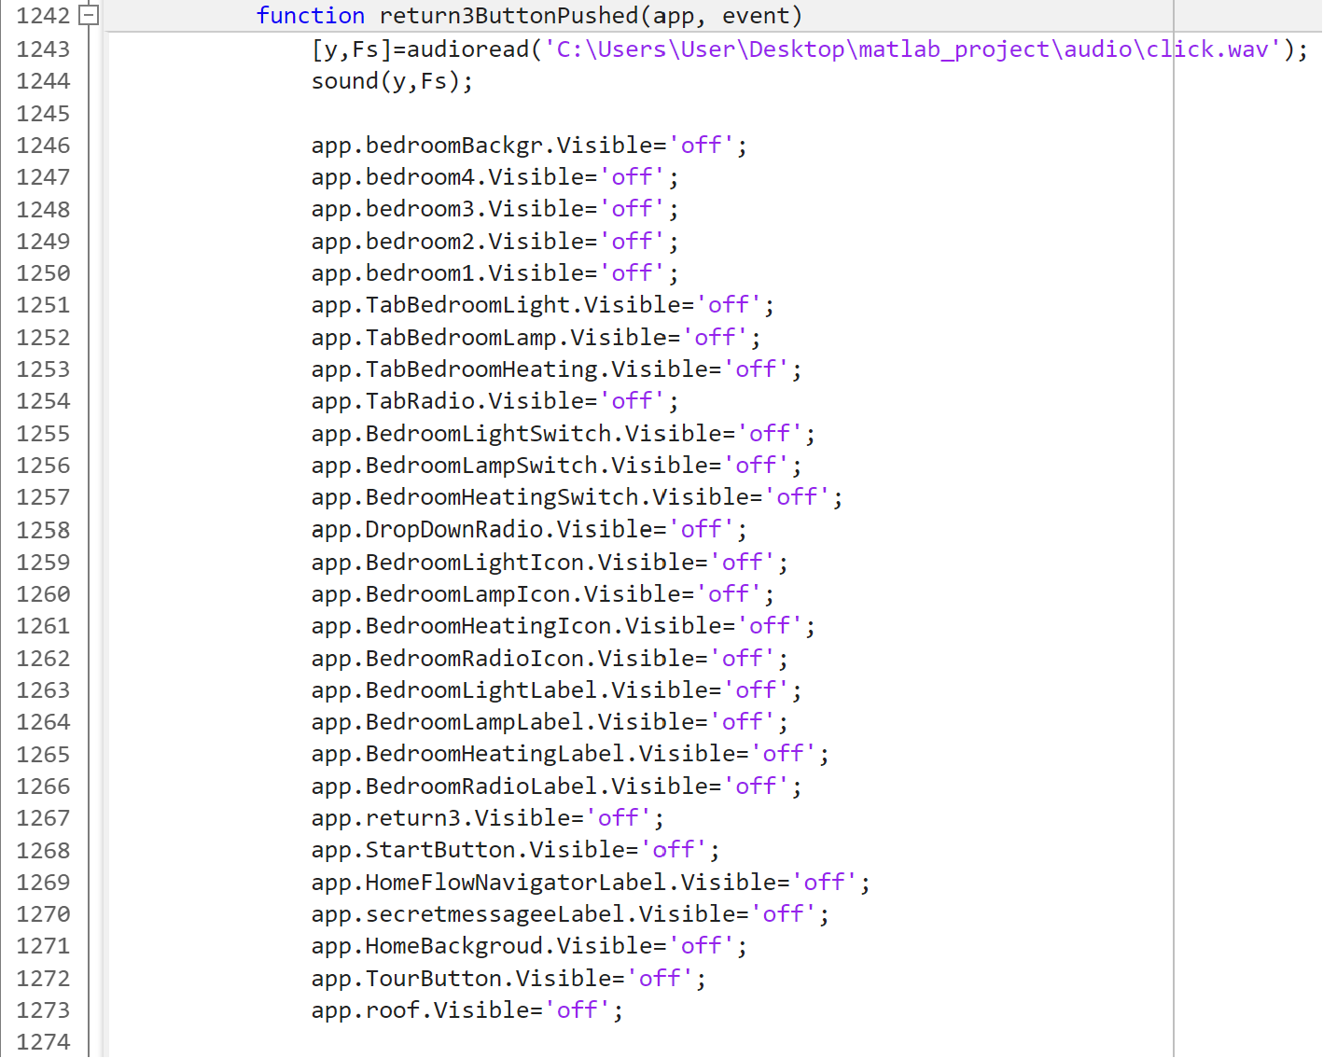

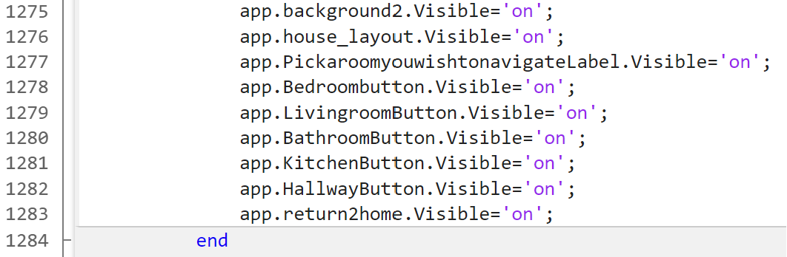

Above is the code for the return button in the bedroom page.

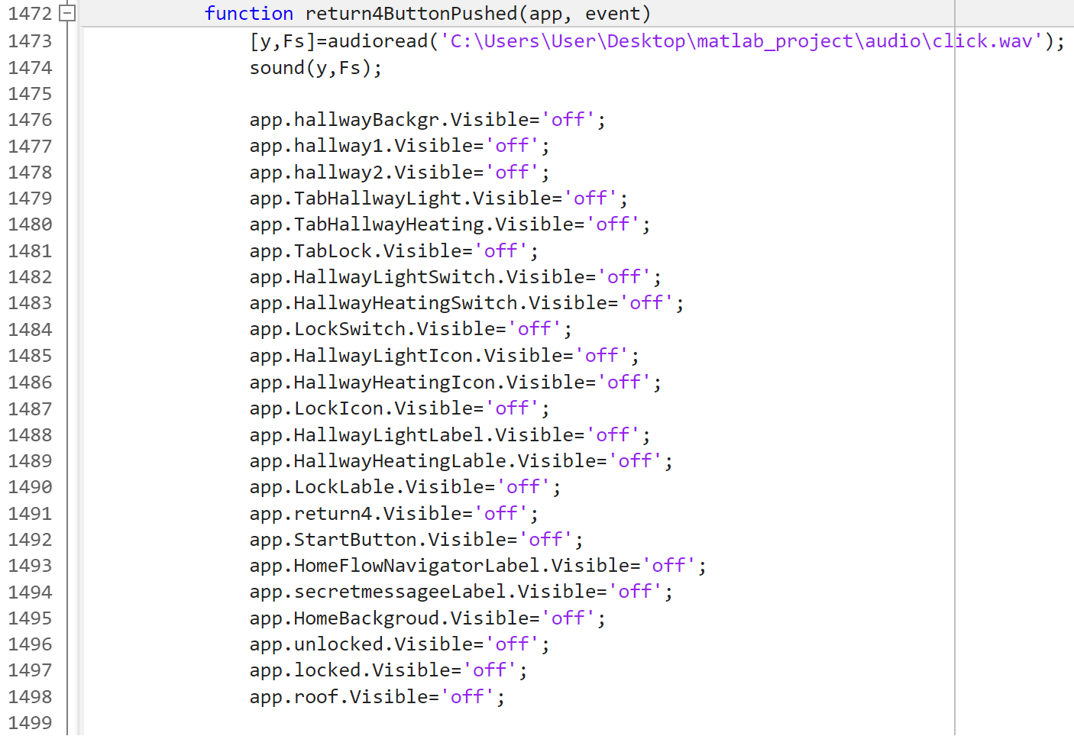

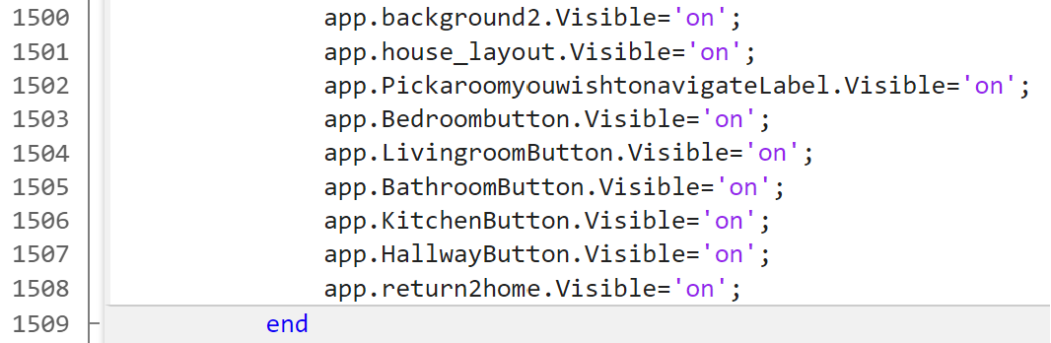

Above is the code for the return button in the hallway page.

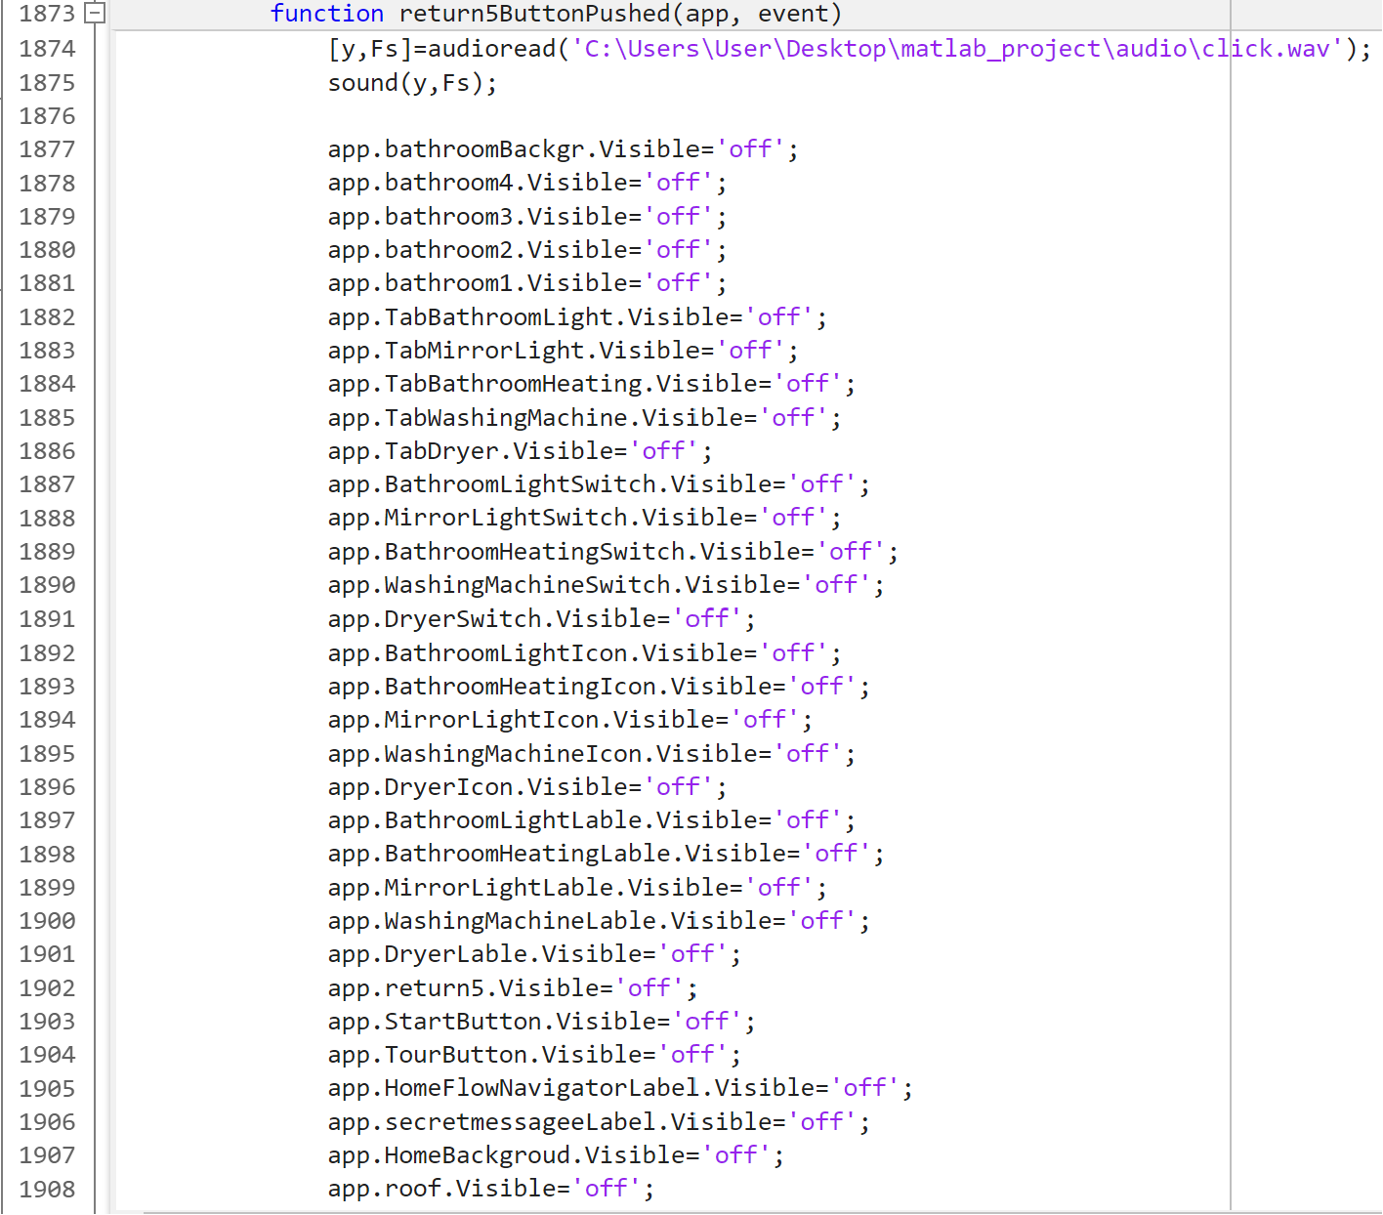

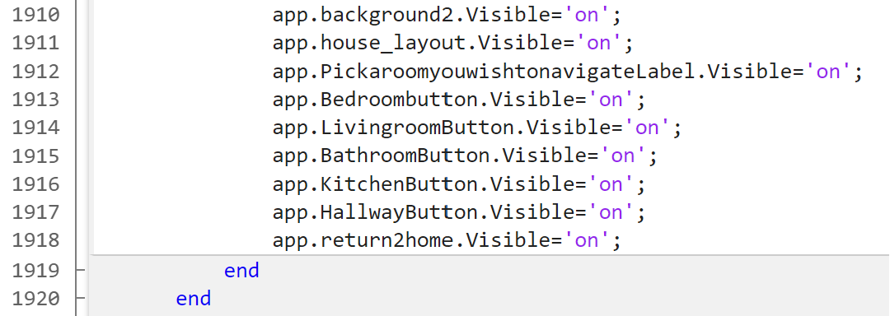

Above is the code for the return button in the bathroom page.

As it can be seen, each return button functions in the same way, the only difference being in which components are being set to visible and non-visible. The reason that every new return button requires setting all of the previous components as invisible is because they are placed above the current ones. They must be included as well, otherwise a room would need to be ‘exited’ and ‘re-entered’ multiple times before getting to the room desired.

* 1. Room buttons

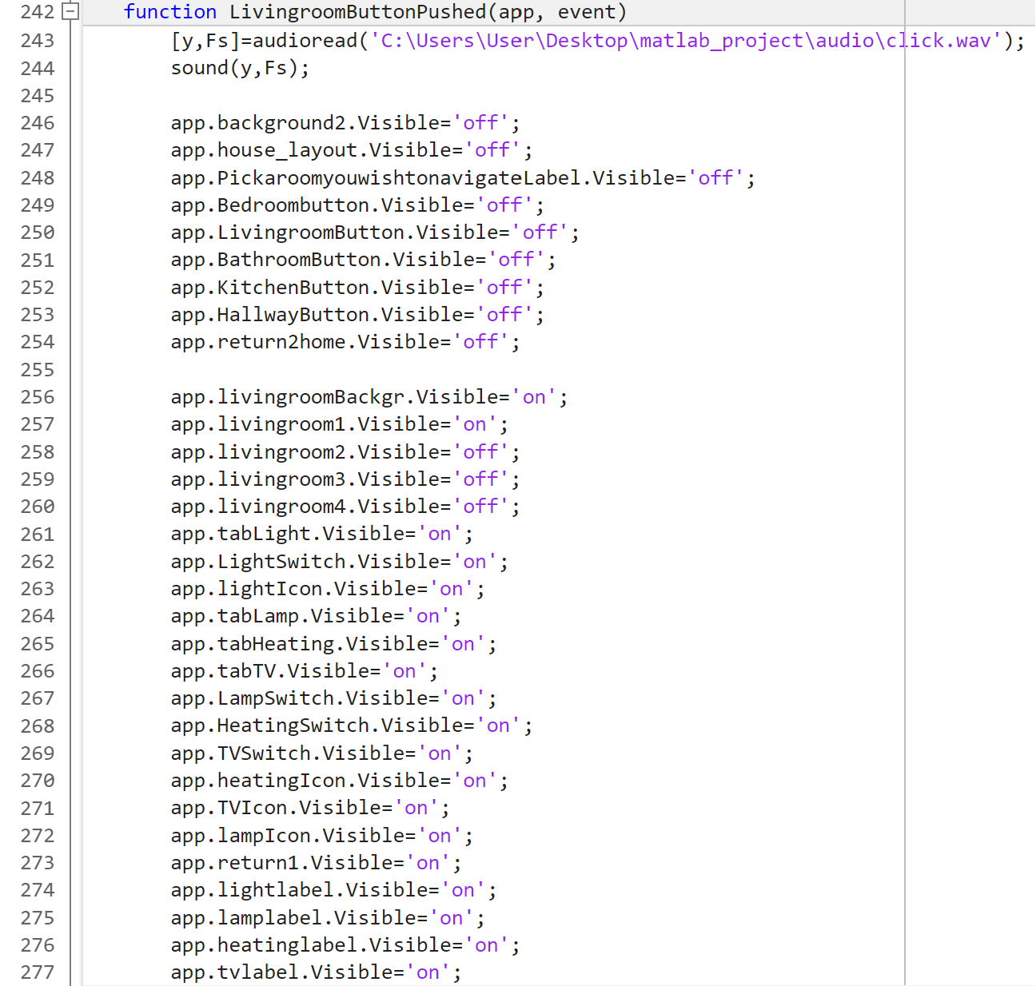

From line 246 to line 254 contain the visibility property of the components that make up the house layout page of the app, and once the button is pushed, all these components are set to ‘off’, making them invisible. This allows the components located below to now be set as visible. This is done in the lines 256 through 277 (excluding components app.livingroom2, app.livingroom3 and app.livingroom4). All of these app components make up the living room page in the app.

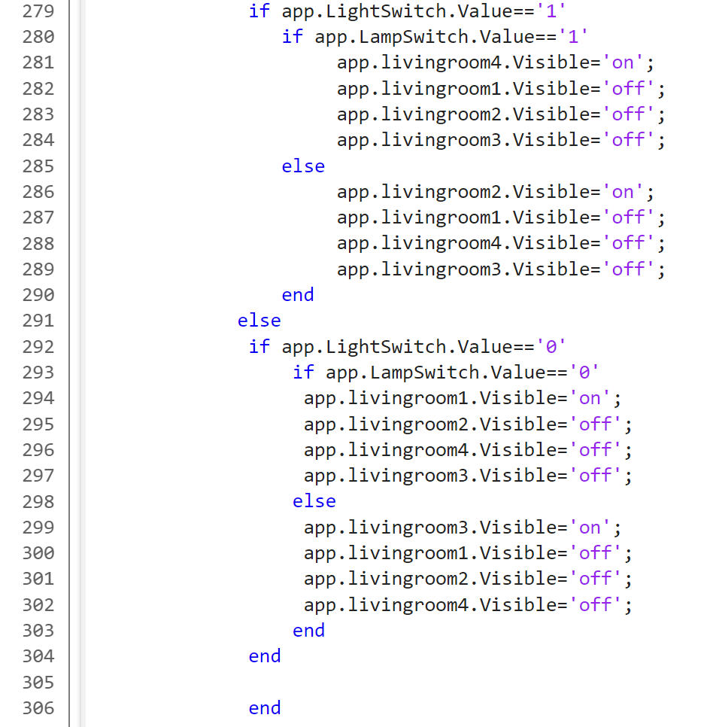

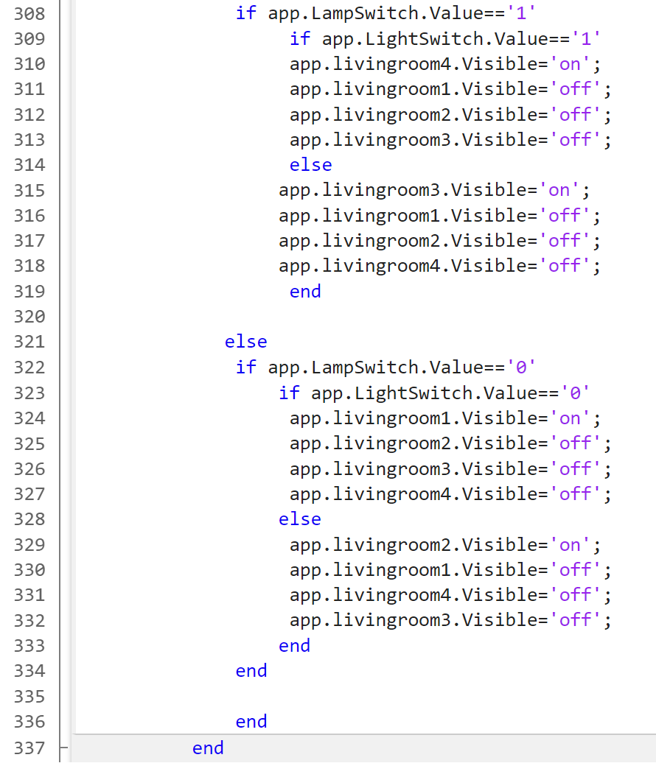

This part of the code is included for every button. Its explanation is located in the “Switch components” part of the report because the same code was used. It is placed in this part because the switches remain on or off if the ‘room’ is exited. The code is there to check if any switch was left on, and if so to determine which image component will be shown first.

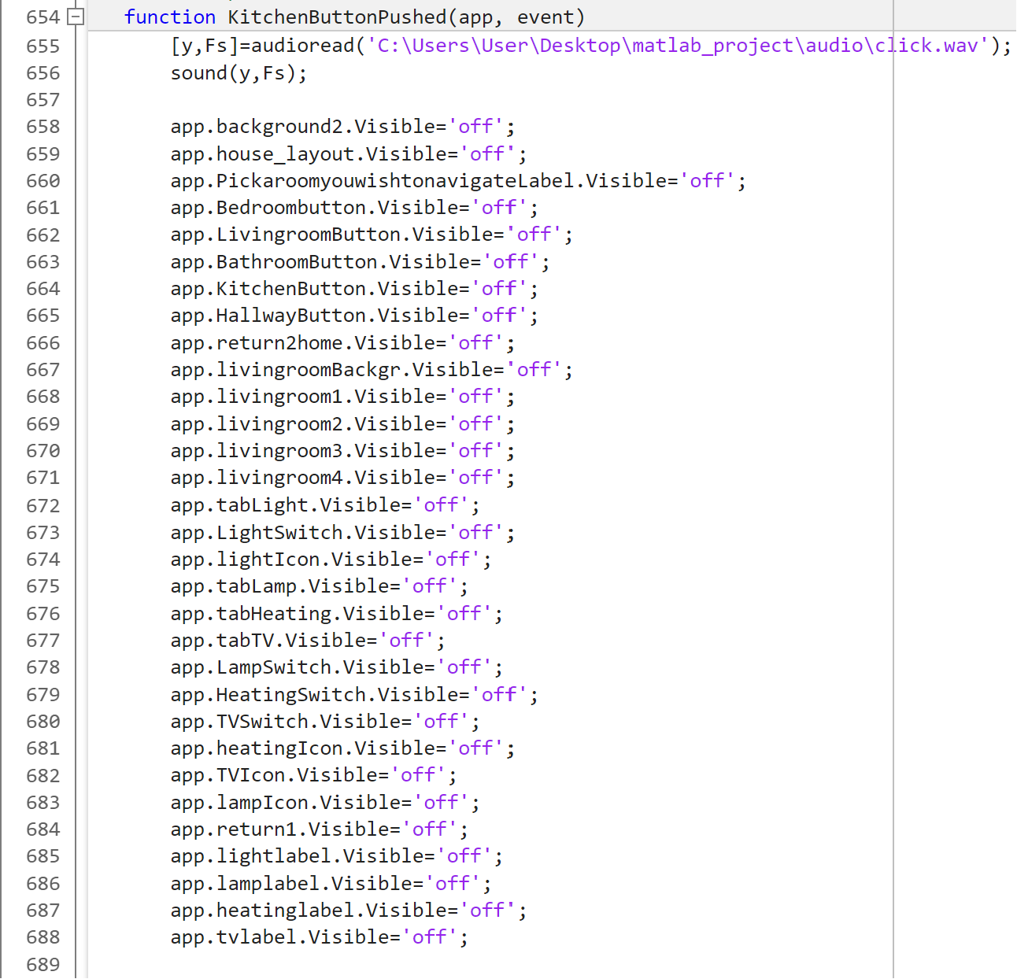

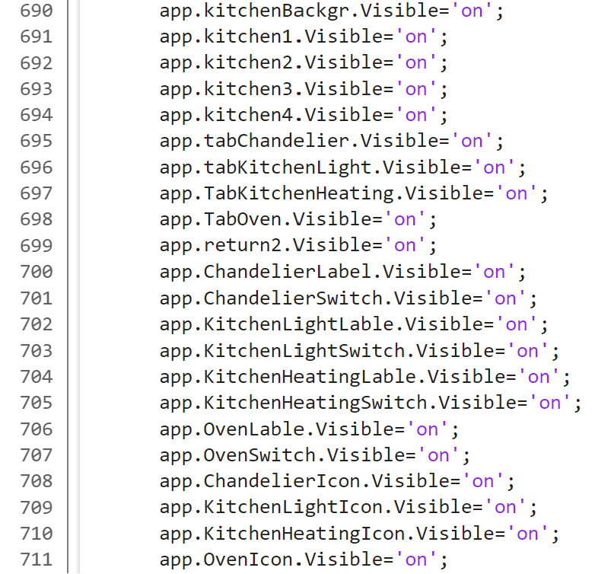

Above is the code for the Kitchen button.

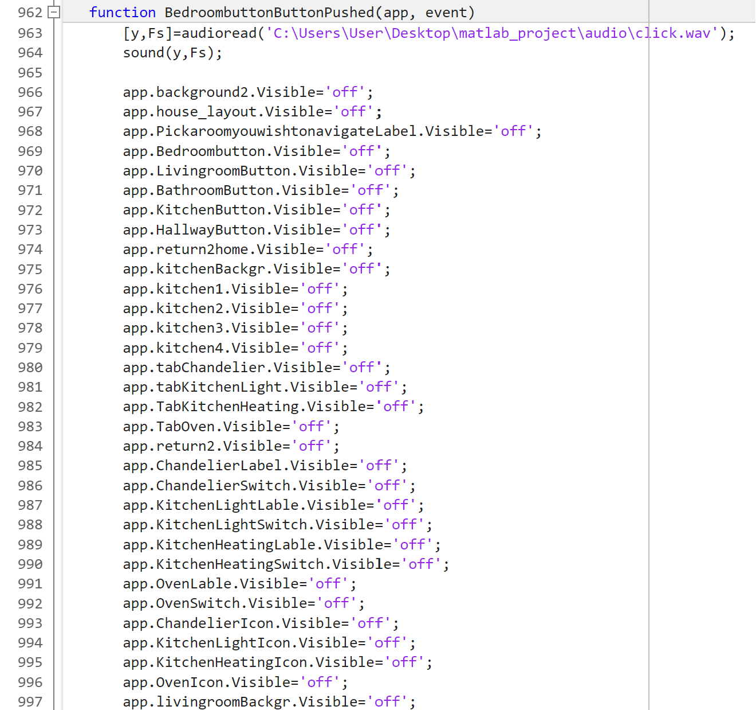

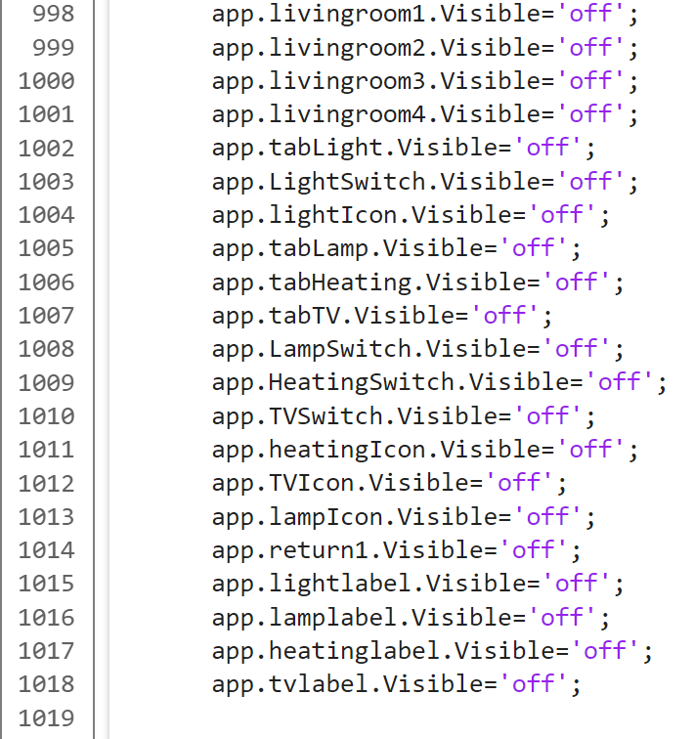

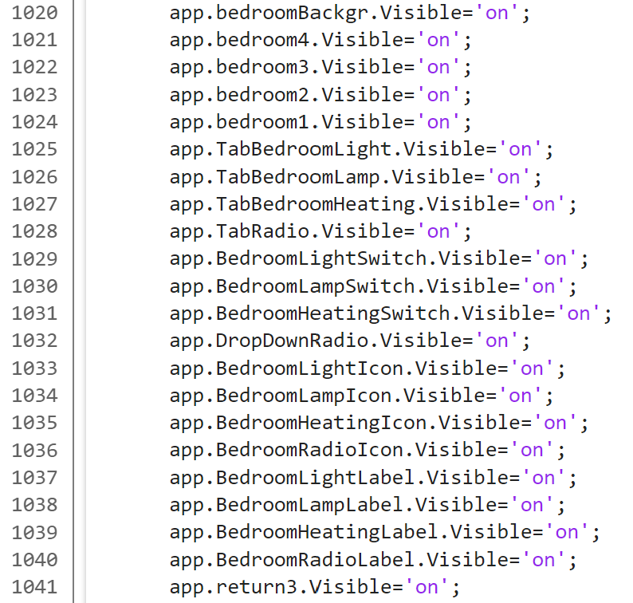

Above is the code for the Bedroom button.

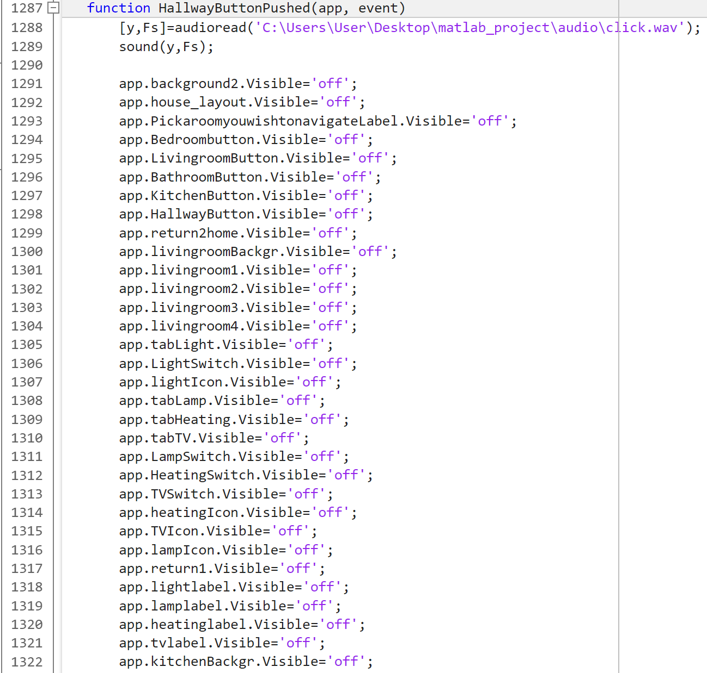

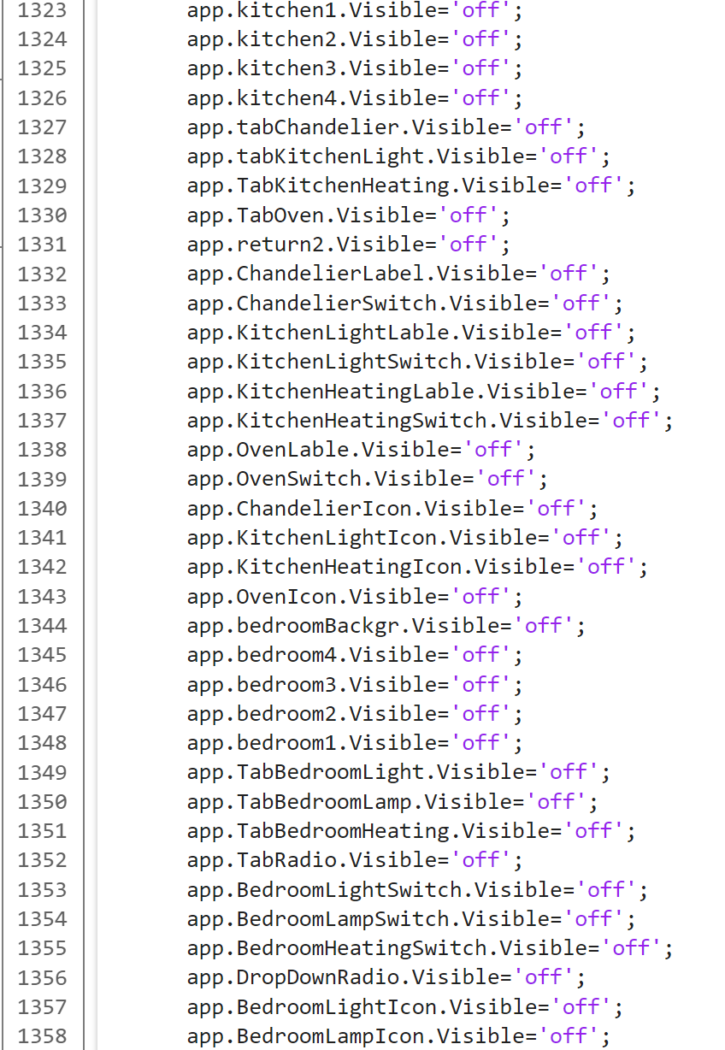

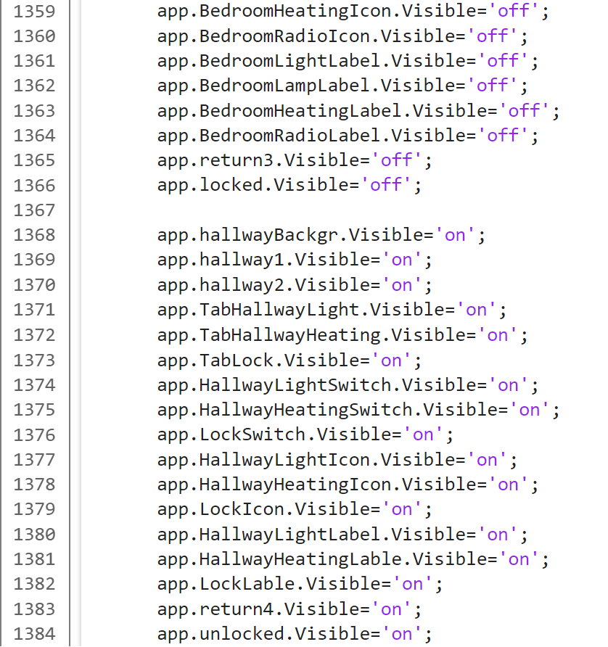

Above is the code for the Hallway button.

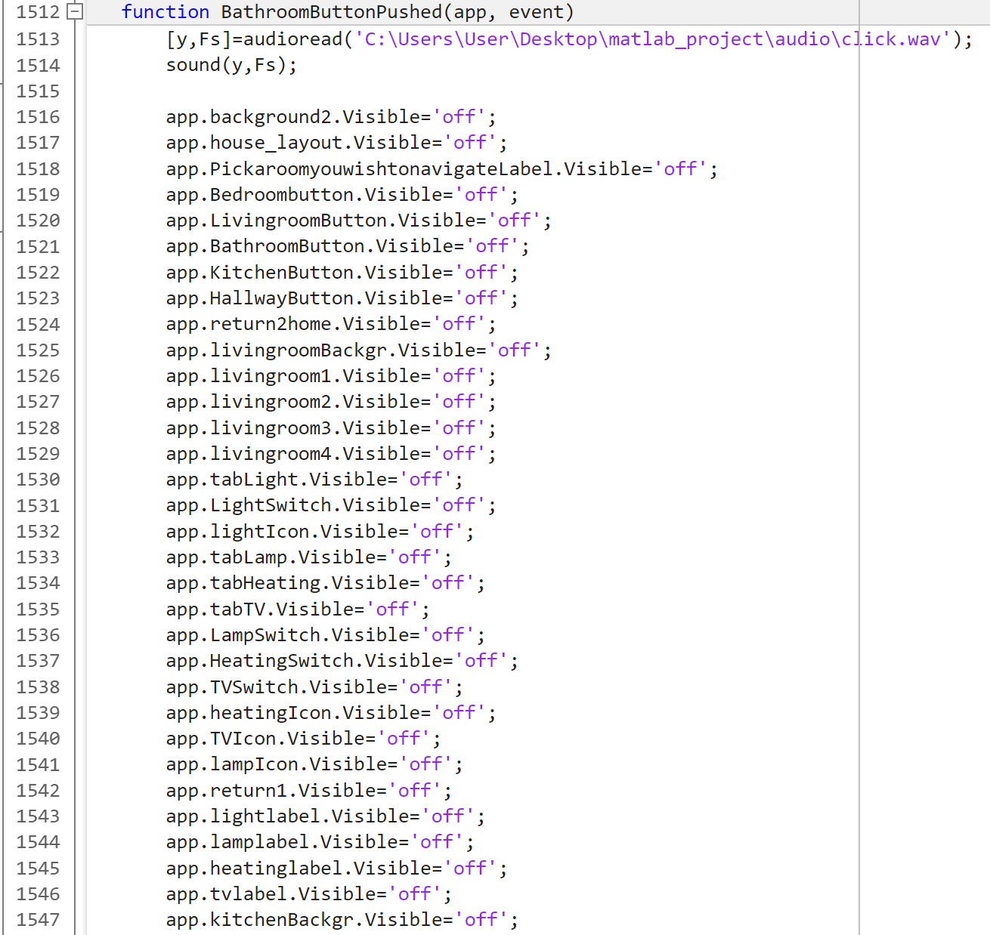

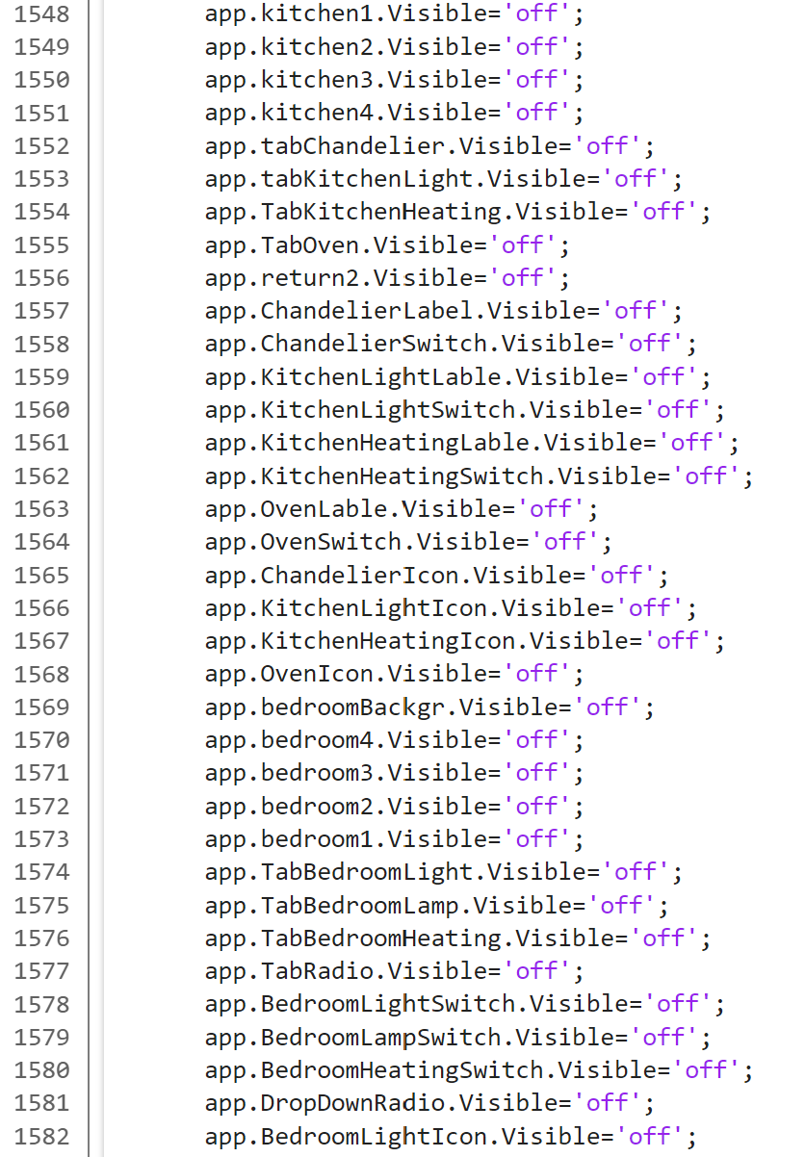

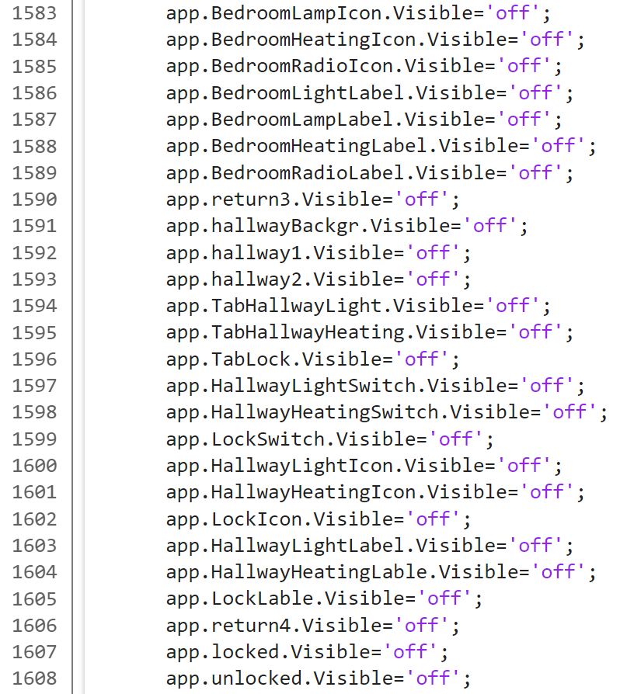

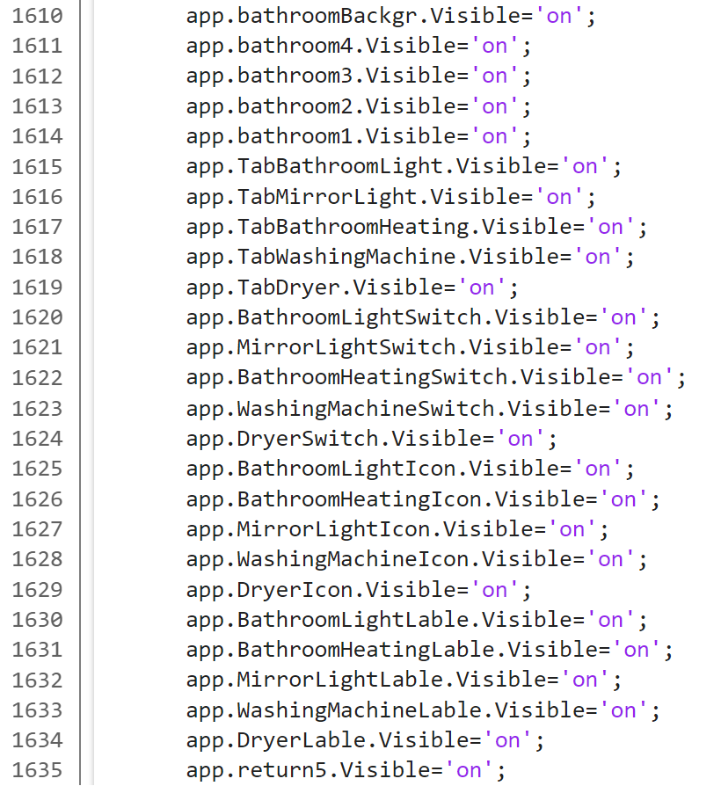

Above is the code for the Bathroom button.

(all of the *if* functions of the buttons have been omitted for this part as they will be available in the next part of the report)

* 1. Switch components

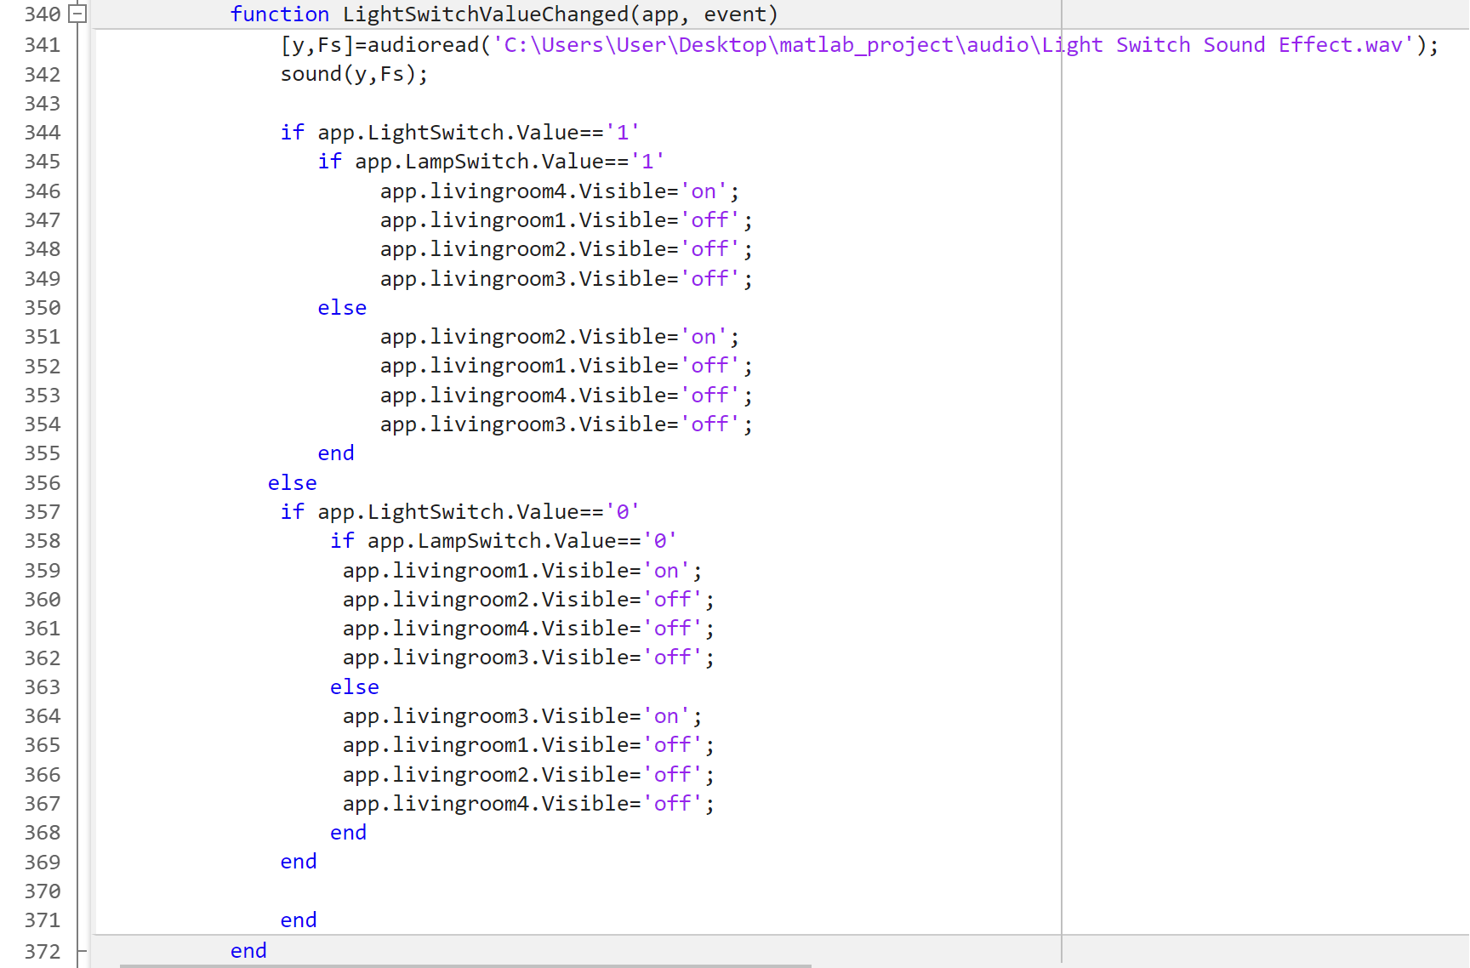

This part of code works as a way to check whether any of the light switches used in the living room have been left on. By using the *if* function, the program will first check if the value of the light switch in the living room is set to 1 (in other words to see if the switch is on). In case of true, the program will then enter another *if* function to check whether the other light source switch, in the case of living room, the lamp switch value is also set to 1. If this is the case, then the code says to change the visibility property of the four images used for the living room. If both light switches are turned on, the app.livingroom4 component will be shown as that is the component that contains the picture when both lights are turned on. The rest of the components’ visibility will be set to ‘off’, making them invisible to the user. If the case of LampSwitch.Value being 0(meaning the lamp is turned off), then the program will do the *else* part of the function. This means that the component set to visible will be the image that shows only the main light turned on in the living room (this case it is image livingroom2).

Furthermore, if the light switch value is not 1, then the function goes to *else* which contains another *if* function. In this function, the value of the light switch is checked again. If the value is 0, then it enters another *if* function. In this function it checks if the lamp switch value is also 0. If the case it that both switches are turned off, then the image shown will be the one that has both lights turned off (livingroom1). If the value of the lamp switch is 1, meaning it is on, then the visibility of all components will be set to 'off', except the app.livingroom3, which is the image where only the lamp is turned on.

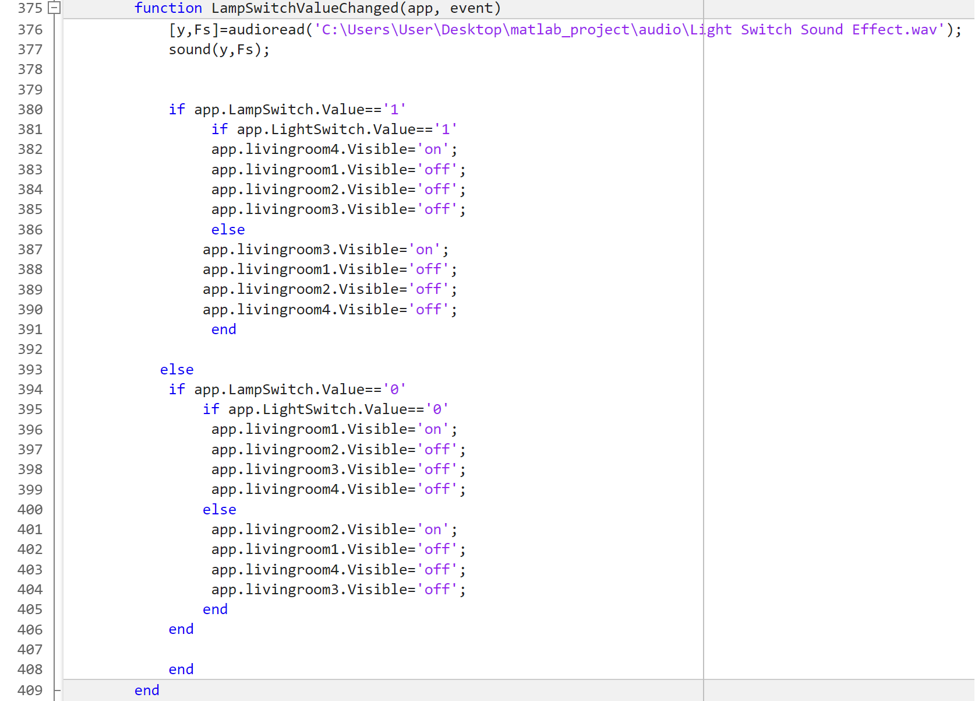

In the same way, this piece of code checks whether any lights have been left on when entering the living room page. The exception is that this time, the component that will be set as visible depends primarily on the value of the lamp switch instead. In case of the lamp switch value being 1, the program checks for the value of the light switch. If its value is also 1, then it will set the visibility ‘on’ for the image that has both lights turned on, otherwise it sets the component that only has the lamp on as the visible one. Same as the light switch in the *else* case, if the lamp switch value is 0, it then checks for the light switch value. If its value is also 0, the visible component will be app.livingroom1 where both lights are off, otherwise the shown component will be the image of only the light being on.

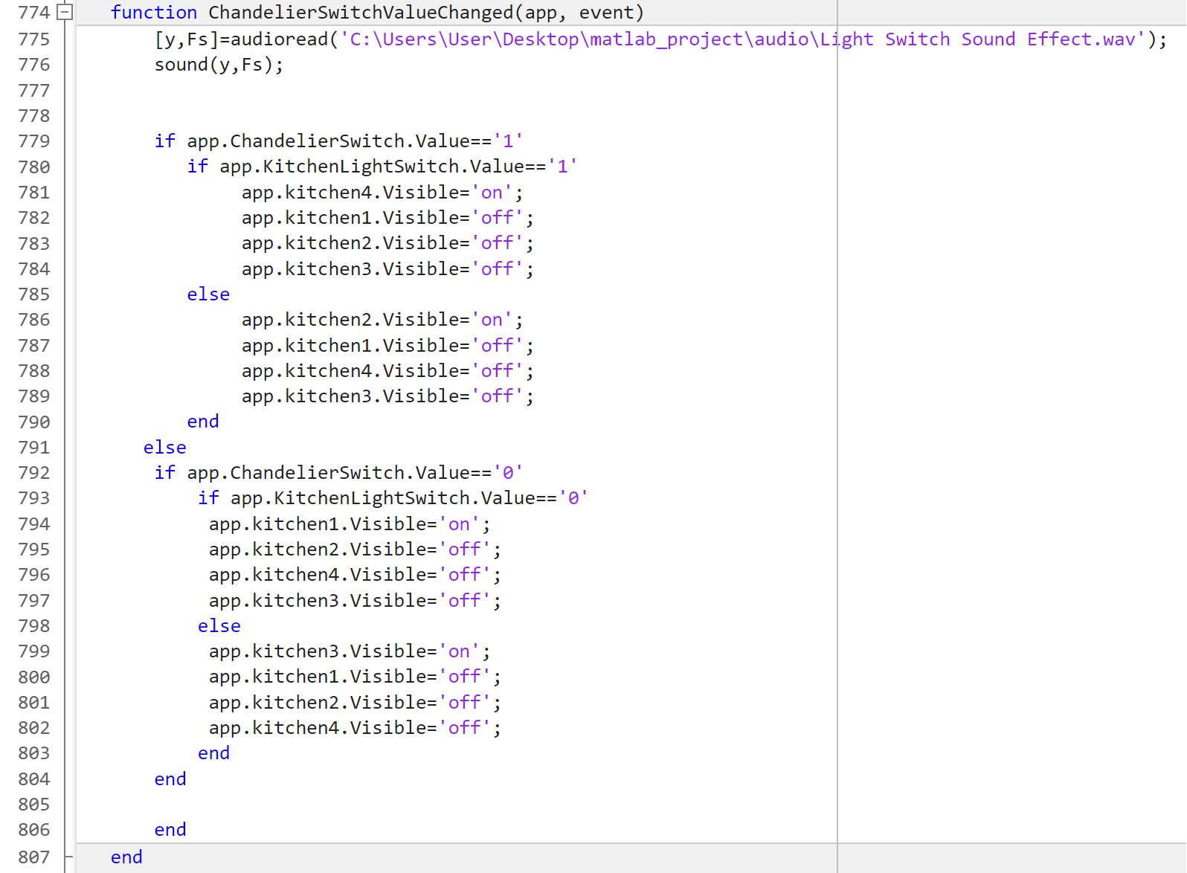

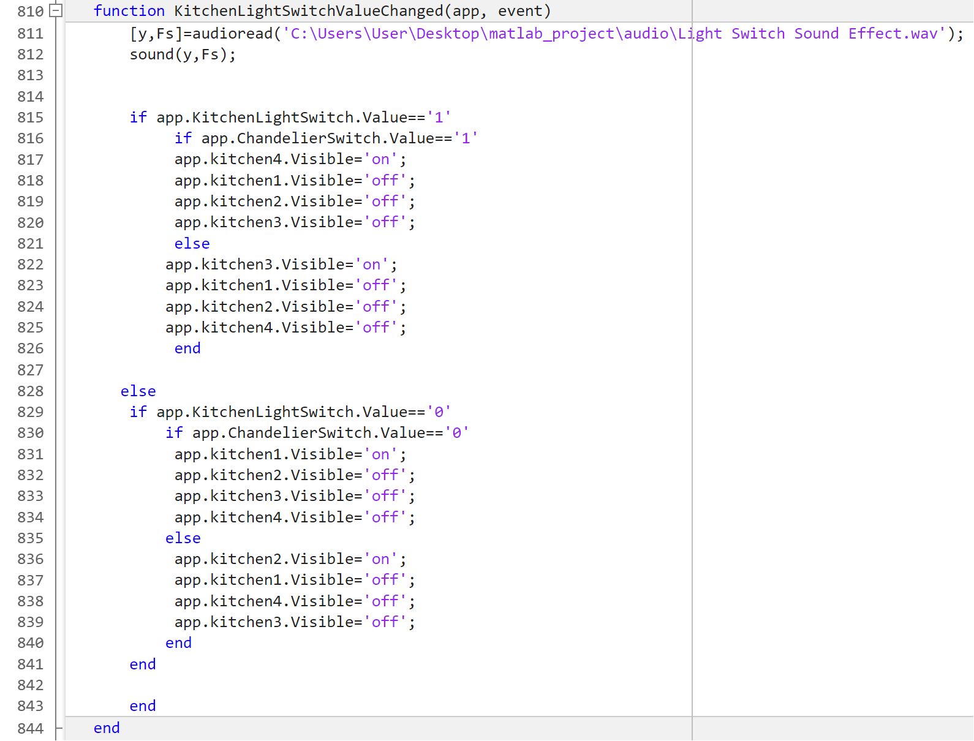

Above is the code for both light switches in the kitchen.

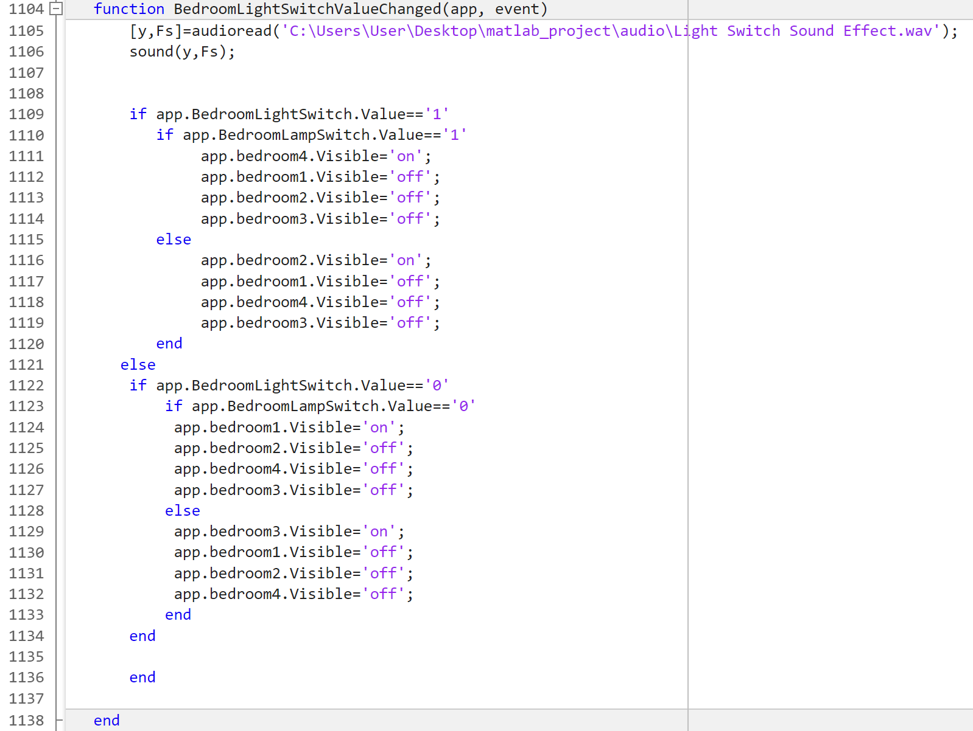

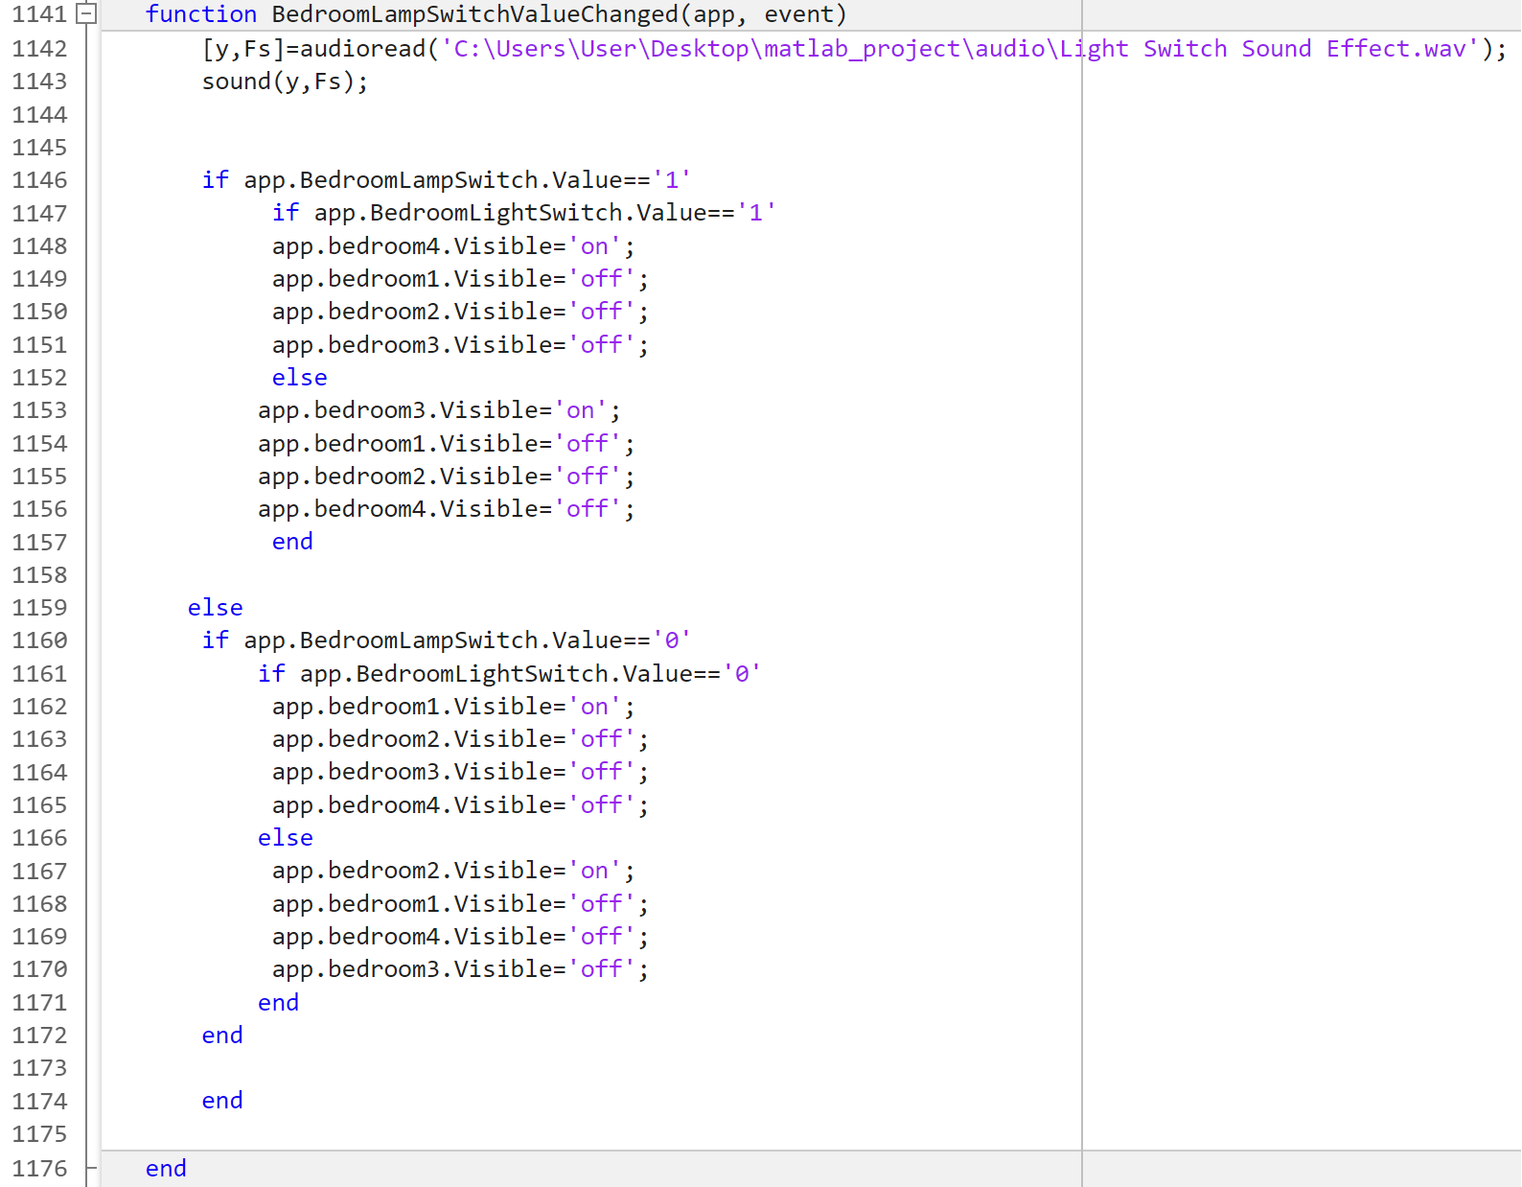

Above is the code for both light switches in the bedroom.

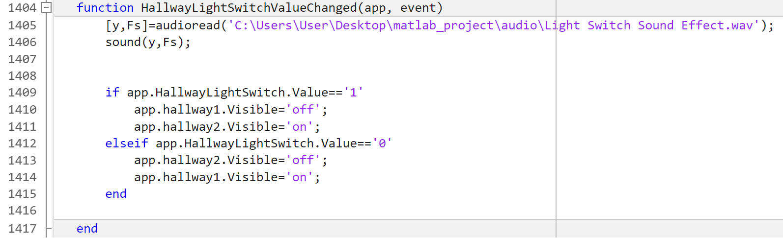

Above is the code for the light switch in the hallway. It differs slightly than the others as it is much more simple in comparison, considering both lights are controlled by a single switch.

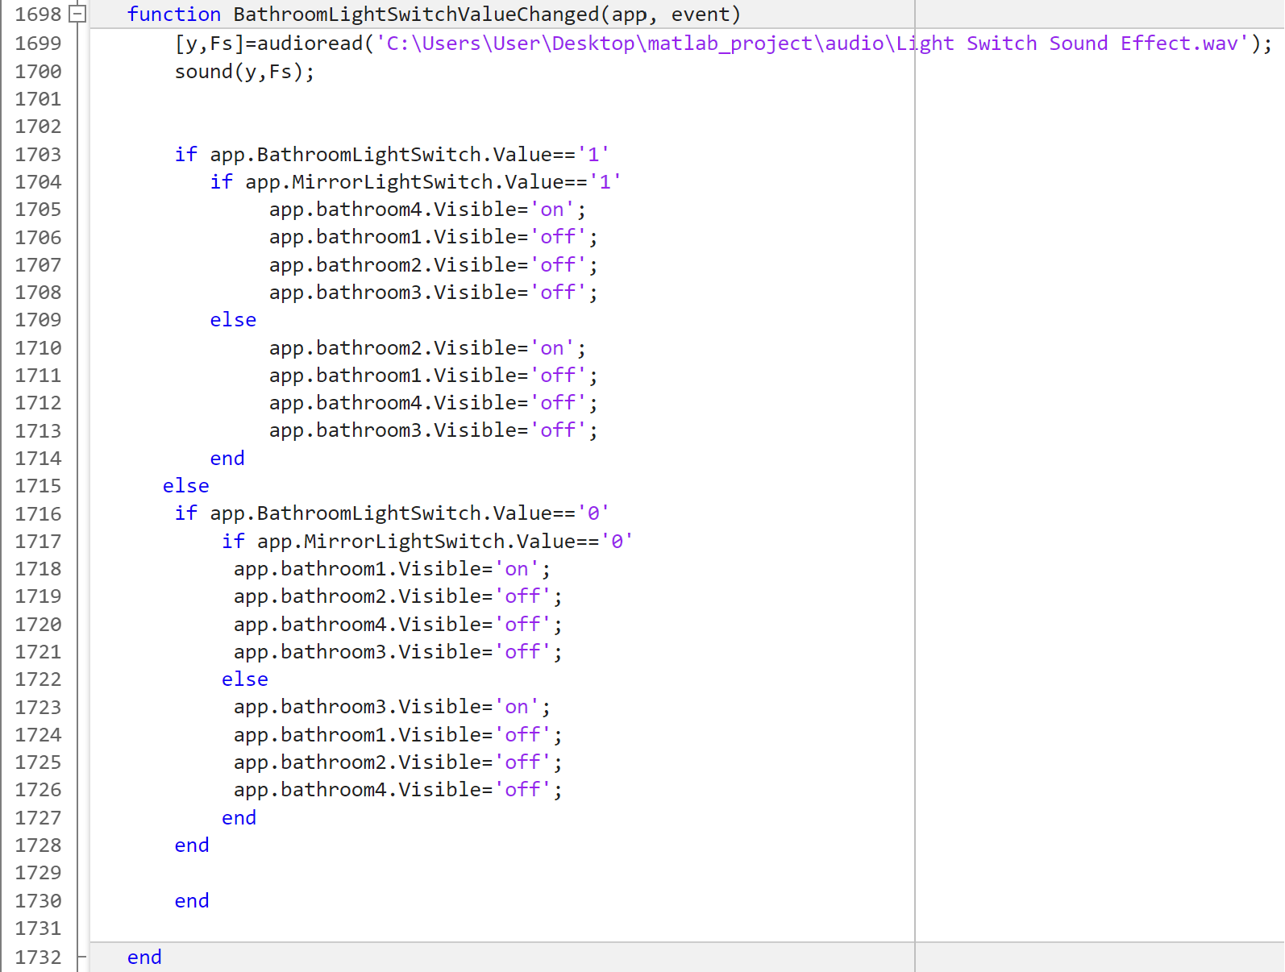

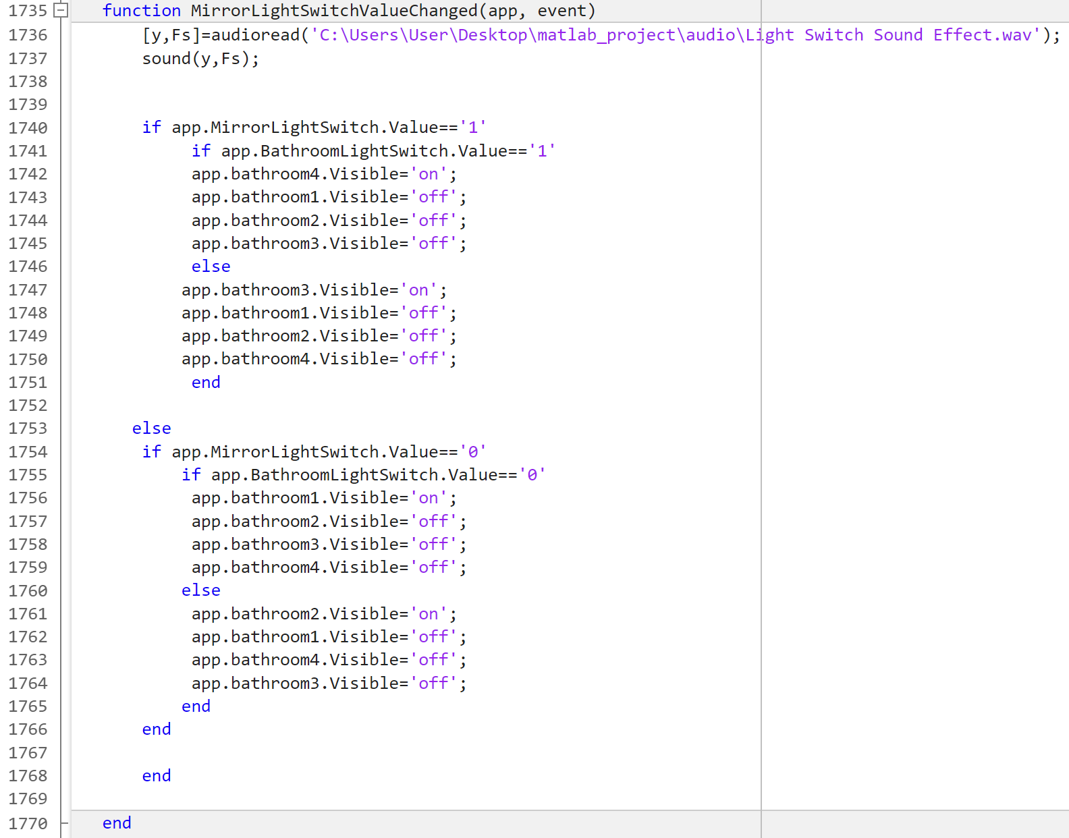

Above is the code for both light switches in the bathroom.

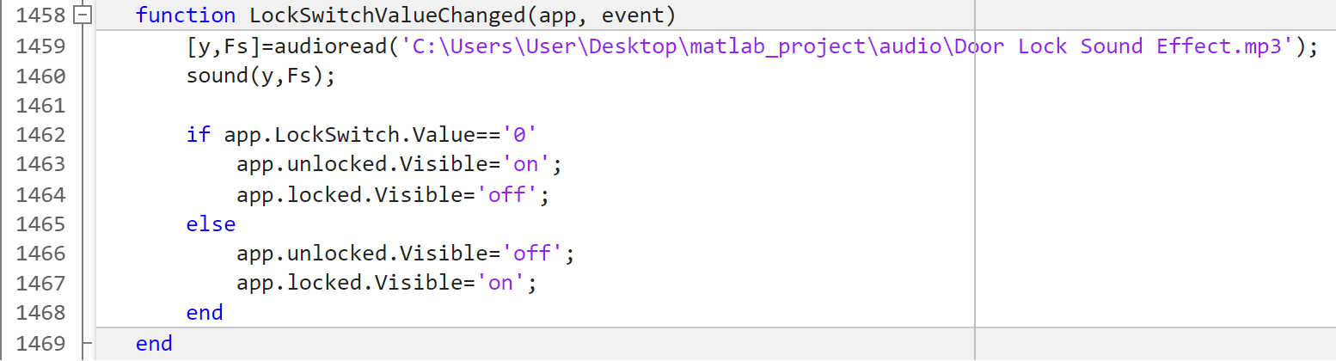

The lock switch component also slightly differs than the code used for the lights. It uses the if function to check for the value of the lock switch, to see whether it is on or off (1 or 0). In case of 0, the small lock icon on the side of the hallway page will be set to an image of a open locket. This serves as an indication that the front house door is unlocked. In the case of the switch value being 1, the image will be changed into a closed locket, meaning the door is now locked.

# **Conclusion**

To summarize, MATLAB App Designer offers a wide range of possibilities available to both beginner and professional programmers. From the ability to create a parking system, to a home automated system or even a coffee machine, MATLAB can inspire, frustrate and even excite you. In our opinion, this project is a great first year project. It teaches you a new skill and helps differentiate the good and motivated future programmers and engineers from those less suited for these majors. Every idea leads to a new one and so this app can be designed and expanded on in multiple ways. Whether that is by changing the code to something shorter and more sophisticated to adding new features. Clearly, this project is a great stepping stone and one to be refined further in the future.

# **References**

1. <https://www.braidshield.com/blog/smart-home-technology-history>
2. <https://roomstyler.com/3dplanner>
3. <https://www.shutterstock.com/image-vector/vector-line-household-appliances-icons-set-730646215>

1. See reference list no. 2.
2. See reference list numbers 3-